**Introduction to Security Operations and Center**

Overview of Security Operations Center (SOC):- A Security Operations Center (SOC) is a centralized unit within an organization that focuses on monitoring, analysing, and responding to cybersecurity incidents. It functions as a command center for managing and defending against cyber threats in real-time. The primary purpose of a SOC is to identify, analyse, and mitigate security incidents using a combination of technology, processes, and skilled security personnel.

Key features of a SOC include:

1. **Monitoring and Detection**: The SOC continuously monitors an organization's network, systems, and applications to detect potential security threats or vulnerabilities.
2. **Incident Response**: When a potential threat is detected, the SOC team assesses the severity of the incident and coordinates an appropriate response, which may include containment, eradication, and recovery efforts.
3. **Threat Intelligence**: SOC teams use threat intelligence feeds and advanced analytics tools to stay informed of the latest cyber threats and attack techniques.
4. **Forensics and Analysis**: In case of an attack, the SOC performs detailed analysis and digital forensics to determine the scope of the breach, the method used, and how to prevent future incidents.
5. **Continuous Improvement**: The SOC constantly evaluates and enhances security protocols, ensuring they adapt to evolving threats and vulnerabilities.

A SOC typically uses tools such as Security Information and Event Management (SIEM) systems, Intrusion Detection Systems (IDS), and endpoint detection solutions to keep an organization’s digital assets safe.

Role and Responsibilities of SOC Analysts:-

SOC analysts are responsible for monitoring, detecting, and responding to cybersecurity threats. Key duties include:

1. **Monitoring**: Continuously track security alerts and events.
2. **Incident Detection**: Investigate potential security breaches.
3. **Incident Response**: Contain and mitigate threats during security incidents.
4. **Threat Hunting**: Proactively search for vulnerabilities and suspicious activities.
5. **Vulnerability Management**: Identify and help fix weaknesses.
6. **Threat Intelligence**: Stay updated on emerging threats.
7. **Forensics**: Analyse breaches to understand attack methods and impact.
8. **Reporting**: Document incidents and responses for future reference.

SOC Architecture and Components:- The architecture of a Security Operations Center (SOC) includes various components and systems designed to monitor, detect, and respond to cyber threats. It’s structured to ensure real-time threat detection, efficient incident response, and ongoing security management.

**Key Components of SOC Architecture:**

**1. Security Information and Event Management (SIEM)**

* Centralizes log collection and analysis.
* Correlates data from various systems to detect security incidents in real-time.

**2. Intrusion Detection/Prevention Systems (IDS/IPS)**

* Monitors network traffic to detect and block malicious activities.

**3. Firewalls**

* Act as the first line of defense, controlling incoming and outgoing traffic based on security rules.

**4. Endpoint Detection and Response (EDR)**

* Monitors and protects endpoints (computers, mobile devices) from threats.
* Provides real-time detection and automated response to threats on endpoints.

**5. Threat Intelligence Platform (TIP)**

* Gathers and provides insights on emerging threats, vulnerabilities, and attack vectors.
* Helps SOC analysts make informed decisions on threat mitigation.

**6. Security Orchestration, Automation, and Response (SOAR)**

* Automates routine tasks, incident response, and workflow processes.
* Integrates different security tools for efficient incident handling.

**7. Vulnerability Management Tools**

* Scans the network and systems for vulnerabilities and potential exploits.

**8. Forensic Tools**

* Helps in post-incident investigation to determine the cause and extent of breaches.

**9. Network Monitoring Tools**

* Continuously monitors traffic for abnormal patterns or potential security risks.

**10. User and Entity Behavior Analytics (UEBA)**

* Detects unusual behavior from users or entities within the system, helping to identify insider threats or compromised accounts.

**11. Incident Response Platform (IRP)**

* Centralizes incident management and tracks the lifecycle of incidents from detection to resolution.

These components work together to form a comprehensive system for proactive cybersecurity management

Incident Response Frameworks (e.g., NIST, SANS):-

Incident Response Frameworks provide structured approaches for handling cybersecurity incidents. Two widely used frameworks are:

**1. NIST (National Institute of Standards and Technology):**

* **Preparation**: Establish incident response capabilities.
* **Detection & Analysis**: Identify and assess incidents.
* **Containment, Eradication & Recovery**: Limit damage, remove threats, and restore systems.
* **Post-Incident Activity**: Review and improve processes.

**2. SANS:**

* **Preparation**: Plan and build response capabilities.
* **Identification**: Detect and confirm incidents.
* **Containment**: Isolate affected systems.
* **Eradication**: Remove the threat.
* **Recovery**: Restore operations.
* **Lessons Learned**: Analyze and improve for future incidents.

Both frameworks emphasize preparation, quick containment, and continuous improvement.

Introduction to Security Information and Event Management (SIEM) Systems:- Security Information and Event Management (SIEM) systems are tools that collect, analyze, and correlate security data from various sources across an organization. They provide real-time threat detection, incident response, and compliance reporting.

**Key Functions:**

* **Data Aggregation**: Collects logs and event data from networks, devices, and applications.
* **Correlation**: Identifies patterns and anomalies by analyzing data.
* **Alerting**: Generates alerts for suspicious activities.
* **Incident Response**: Helps in investigating and responding to security incidents.
* **Compliance**: Assists in meeting regulatory requirements by tracking security events.

SIEM helps organizations maintain visibility, detect threats, and respond to incidents effectively.

**Practical No. 1**

**Install Splunk Enterprise via the GUI installer**

The Windows installer is an MSI file.

**Begin the installation**

1. Download the Splunk installer from the Splunk [download page](http://splunk.com/download).
2. To start the installer, double-click the splunk.msi file. The installer runs and displays the **Splunk Enterprise Installer** panel.

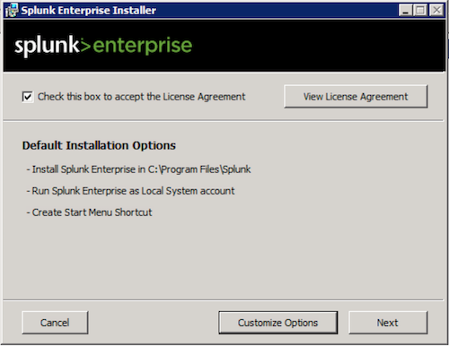

1. To continue the installation, check the "Check this box to accept the License Agreement" checkbox. This activates the "Customize Installation" and "Next" buttons.
2. (Optional) If you want to view the license agreement, click **View License Agreement**.

**Installation Options**

The Windows installer gives you two choices: Install with the default installation settings, or configure all settings prior to installing.

When you choose to install with the default settings, the installer does the following:

* Installs Splunk Enterprise in \Program Files\Splunk on the drive that booted your Windows machine.
* Installs Splunk Enterprise with the default management and Web network ports.
* Configures Splunk Enterprise to run as the Local System user.
* Prompts you to create a Splunk administrator password. You must do this before installation can continue.
* Creates a Start Menu shortcut for the software.

If you want to change any of these default installation settings, click **Customize Options** and proceed with the instructions in "Customize Options" in this topic.

Otherwise, click **Next**. You will be prompted for a password for the Splunk admin user. After you supply a password, installation begins and you can continue with the "Complete the install" instructions later in this topic.

**Customize options during the installation**

You can customize several options during the installation. When you choose to customize options, the installer displays the "Install Splunk Enterprise to" panel.

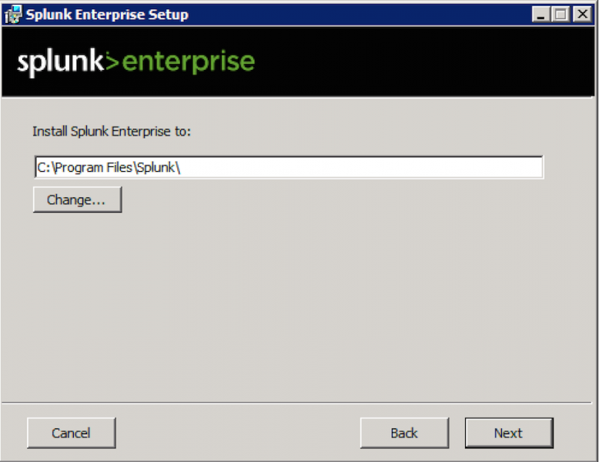

By default, the installer puts Splunk Enterprise into \Program Files\Splunk on the system drive. This documentation set refers to the Splunk Enterprise installation directory as $SPLUNK_HOME or %SPLUNK_HOME%.

Splunk Enterprise installs and runs two Windows services, splunkd and splunkweb. The splunkd service handles all Splunk Enterprise operations, and the splunkweb service installs to run only in legacy mode.

These services install and run as the user you specify on the "Choose the user Splunk Enterprise should run as" panel. You can choose to run Splunk Enterprise as the Local System user, or another user.

When the installer asks you the user that you want to install Splunk Enterprise as, you must specify the user name in domain\username format. The user must be a valid user in your security context, and must be an active member of an Active Directory domain. Splunk Enterprise must run under either the Local System account or a valid user account with a valid password and local administrator privileges. Failure to include the domain name with the user will cause the installation to fail.

1. Click **Change…** to specify a different location to install Splunk Enterprise, or click **Next** to accept the default value. The installer displays the "Choose the user Splunk Enterprise should run as" panel.

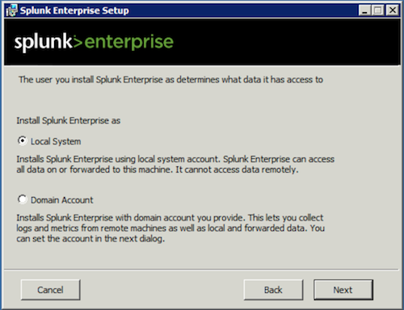

1. Select a user type and click **Next**.
2. If you selected the Local System user, proceed to Step 5. Otherwise, the installer displays the **Logon Information: specify a username and password** panel.

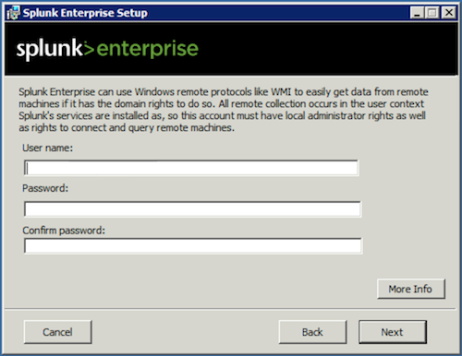

1. Enter the Windows credentials that Splunk Enterprise uses to run on the machine and click **Next**.
2. Create credentials for the Splunk administrator user by entering a username and password that meets the minimum eligibility requirements as shown in the panel and click **Next**.
3. The installer displays the installation summary panel.

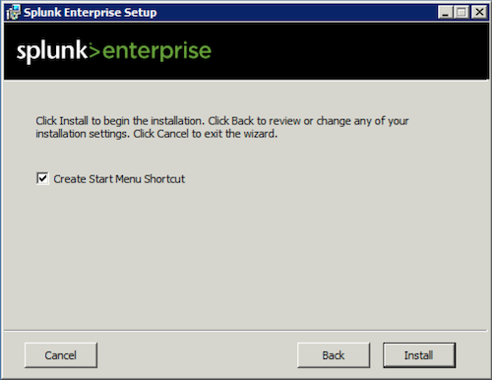

1. Click "Install" to proceed with the installation.

**Complete the installation**

The installer runs, installs the software, and displays the **Installation Complete** panel.

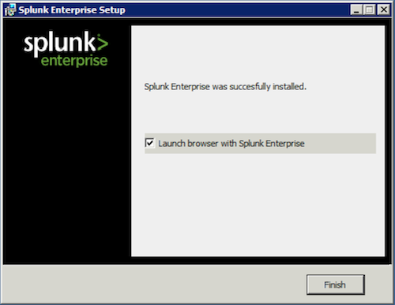

Click **Finish**. The installation completes, Splunk Enterprise starts and launches in a supported browser.

**Practical 2**

Splunk Data

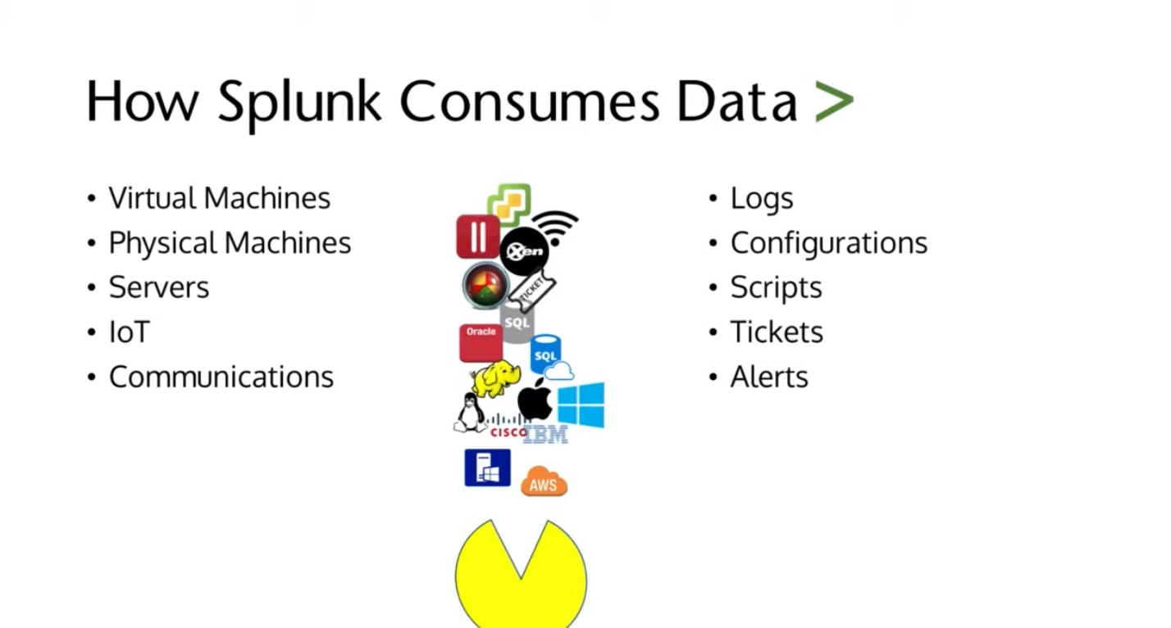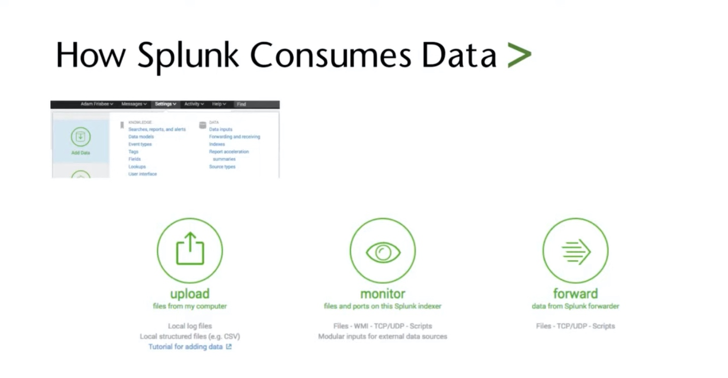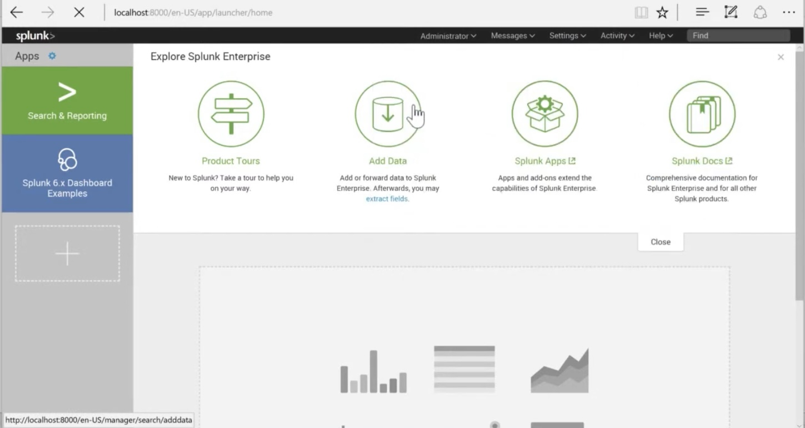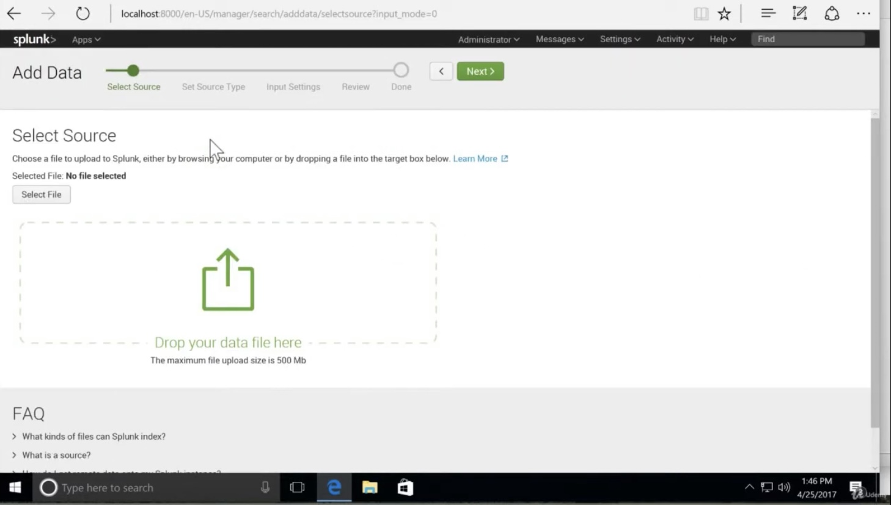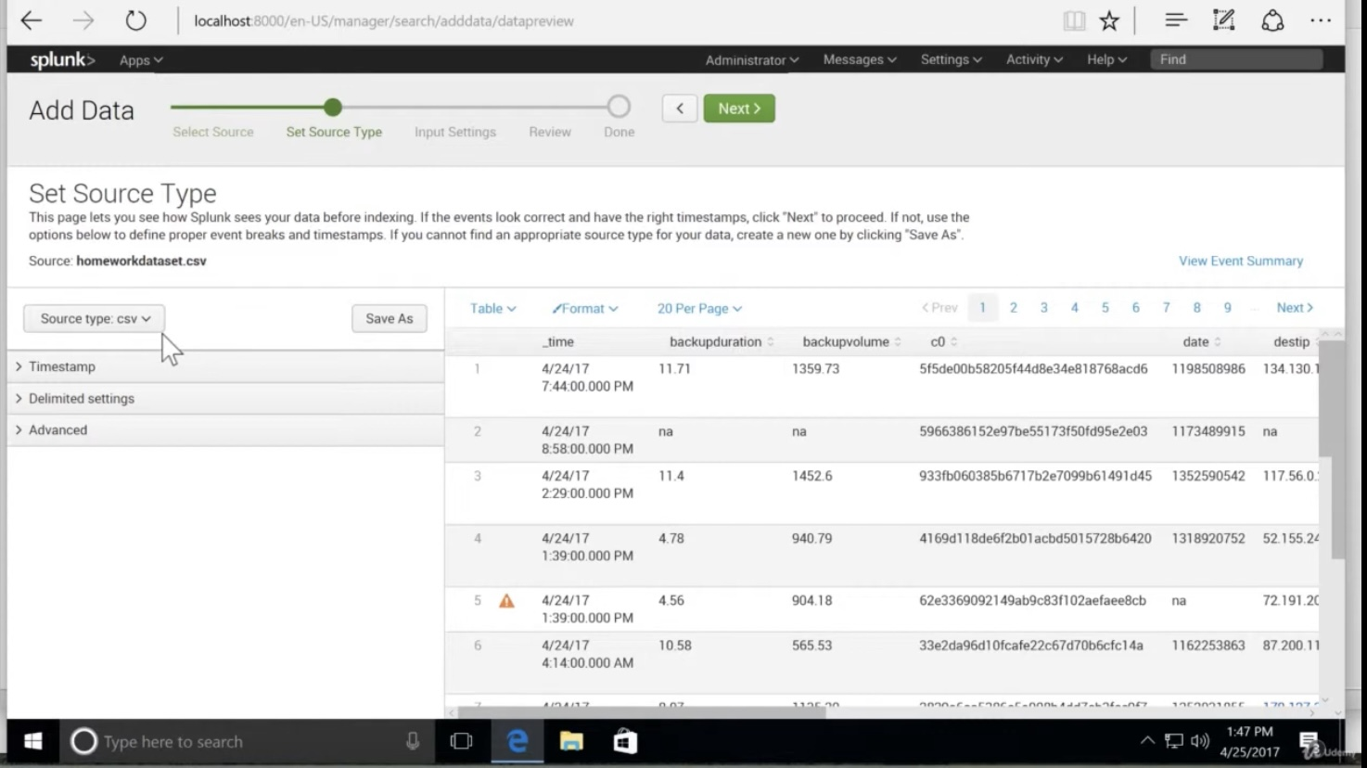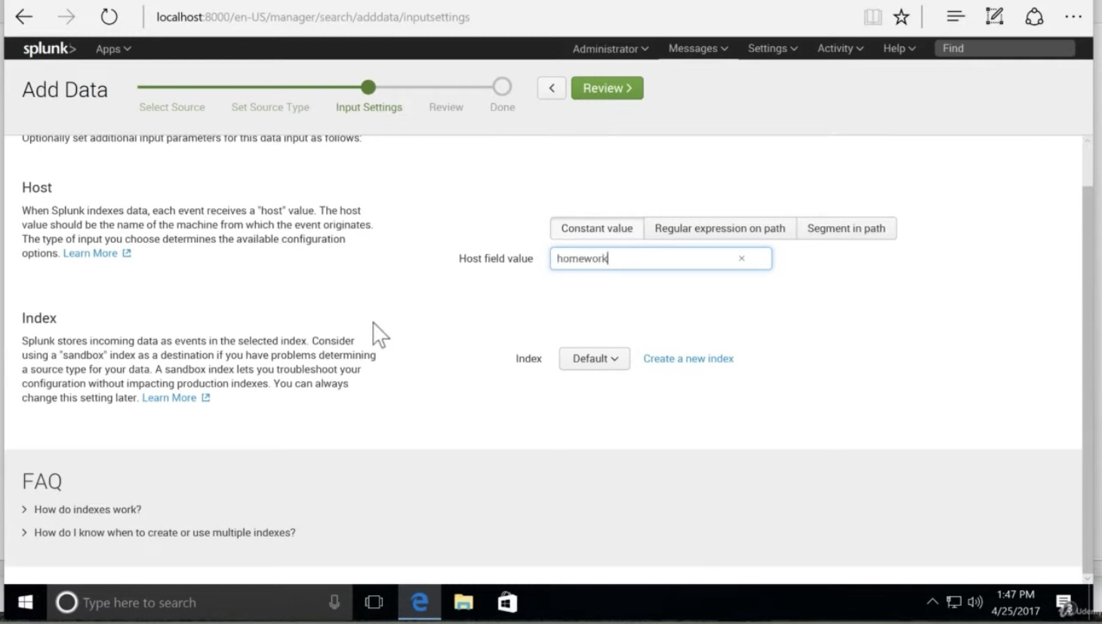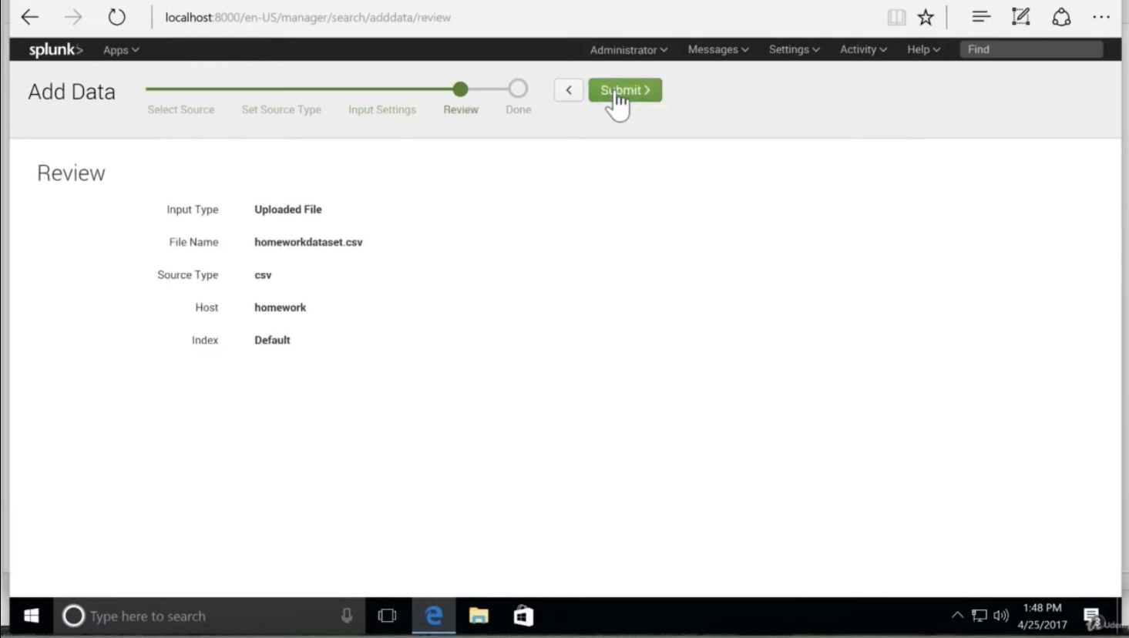

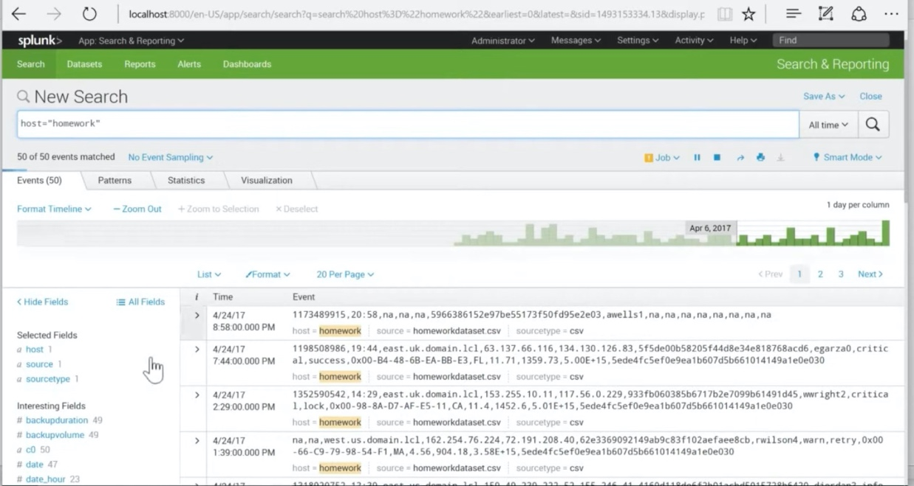

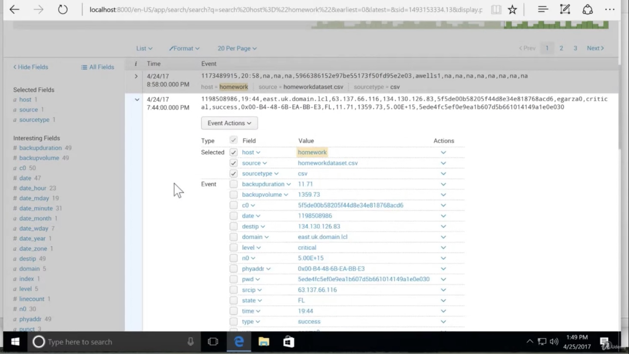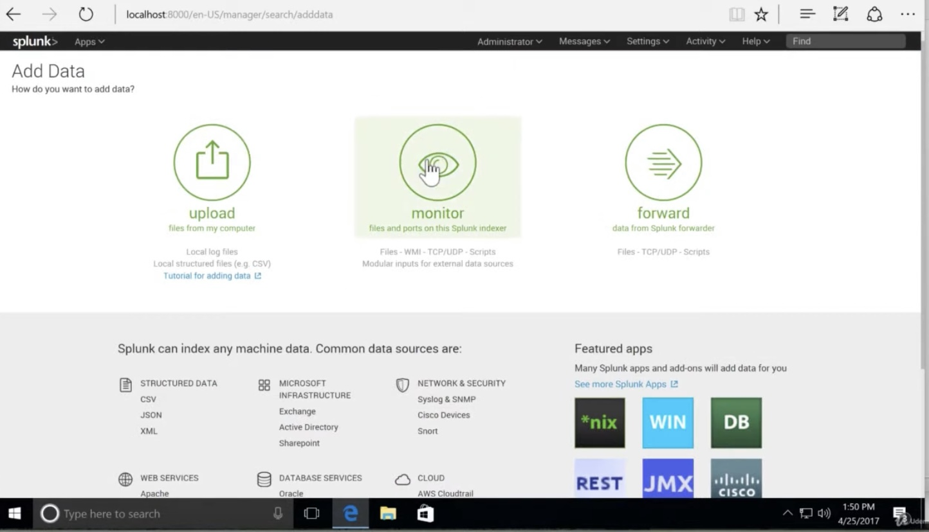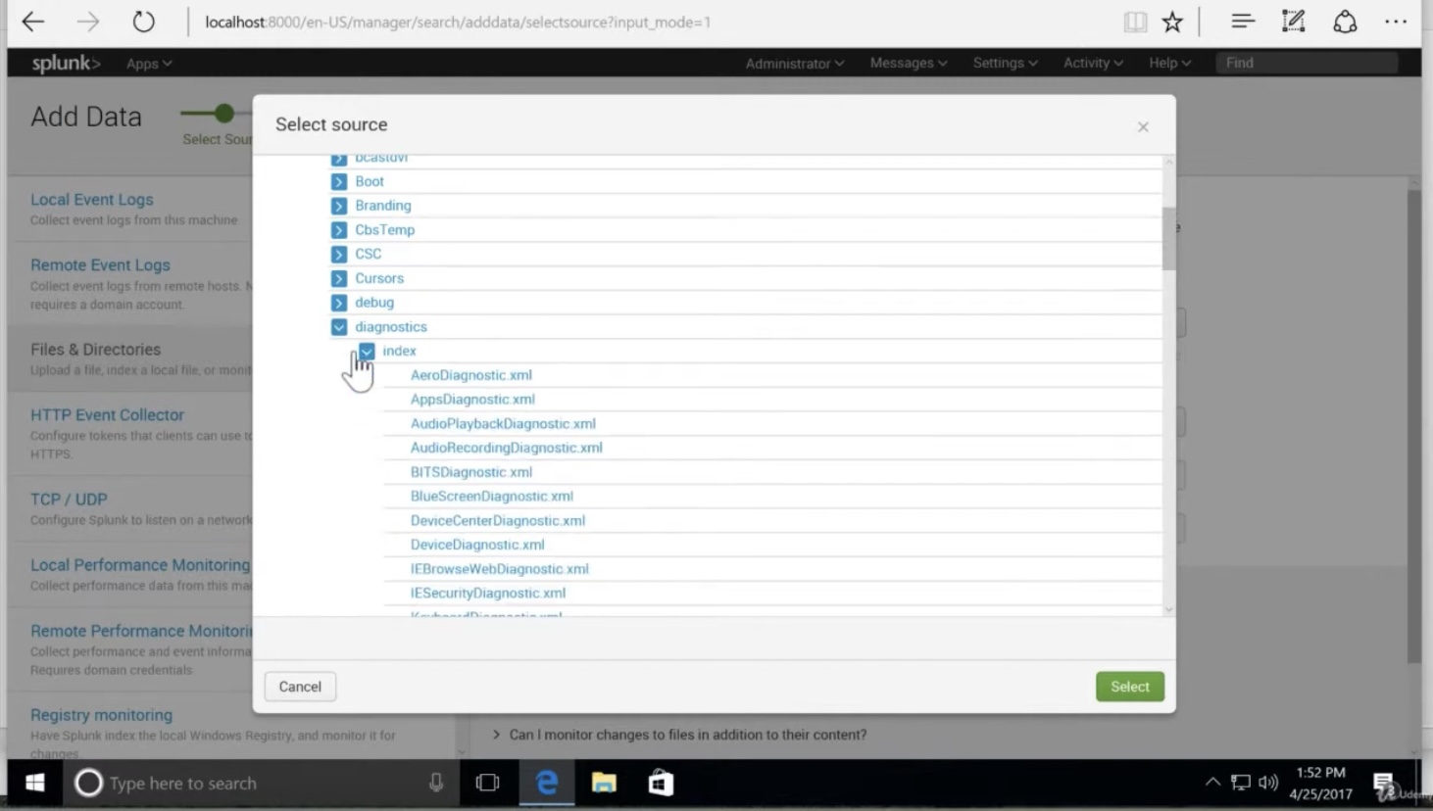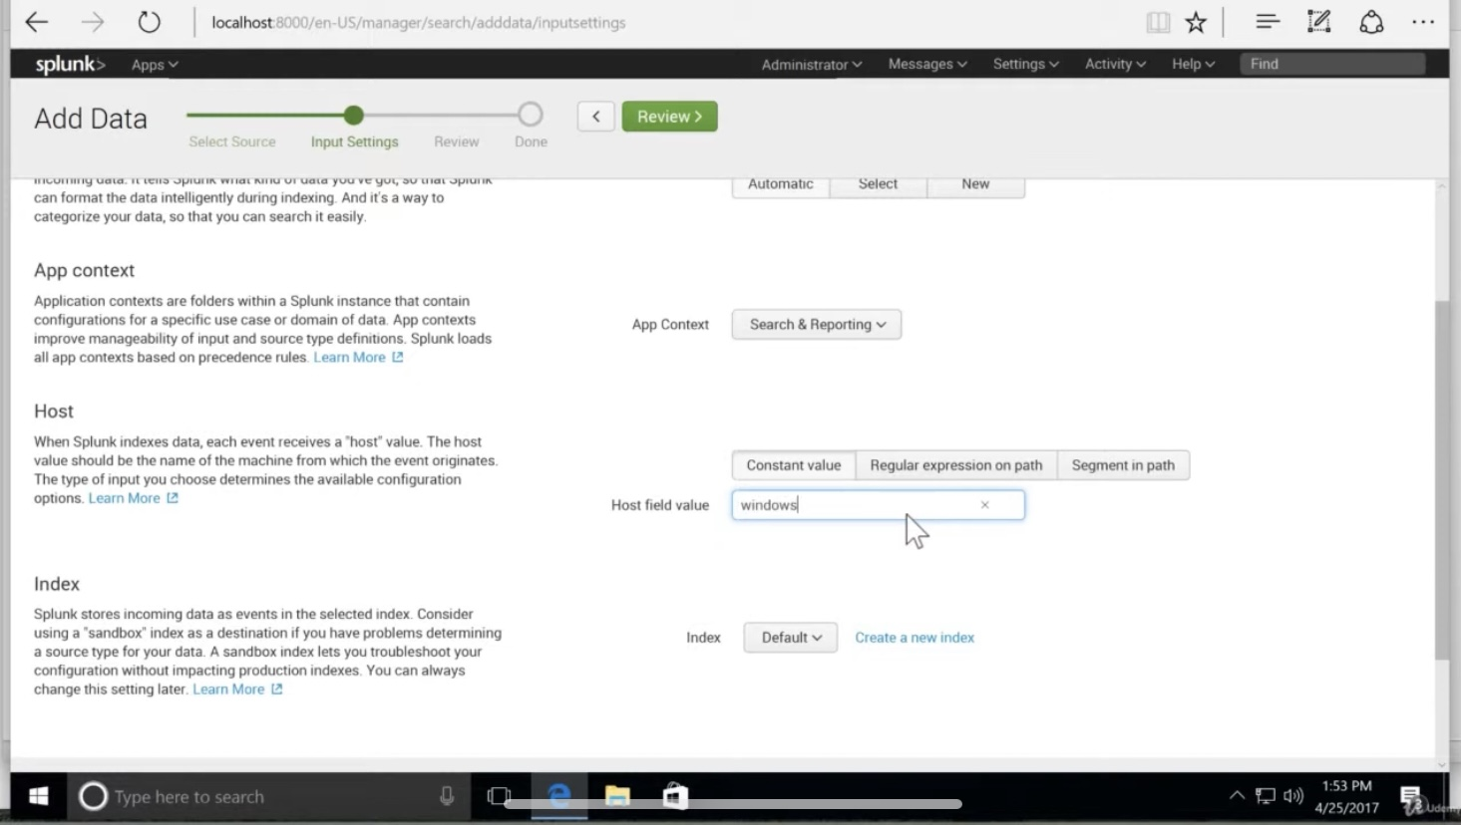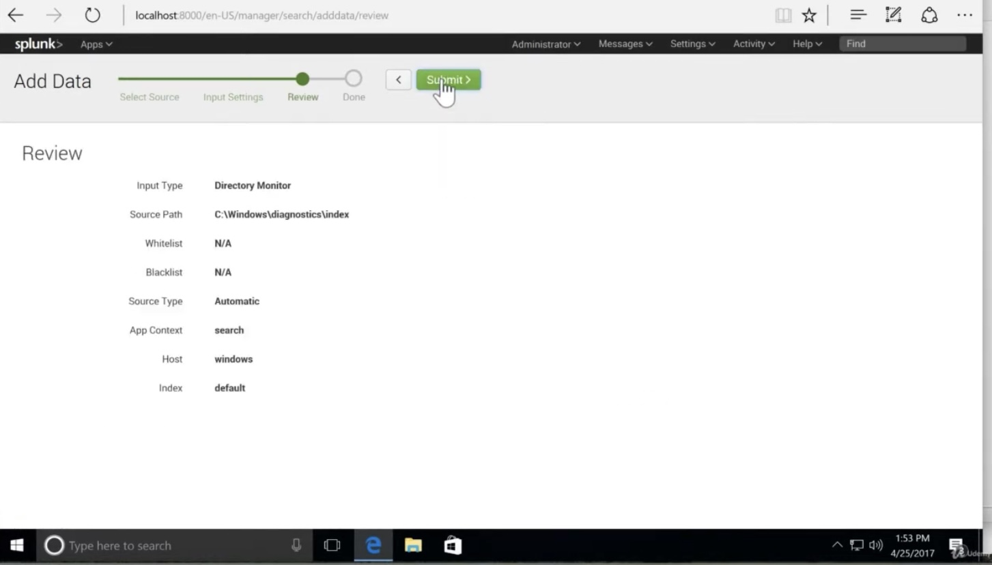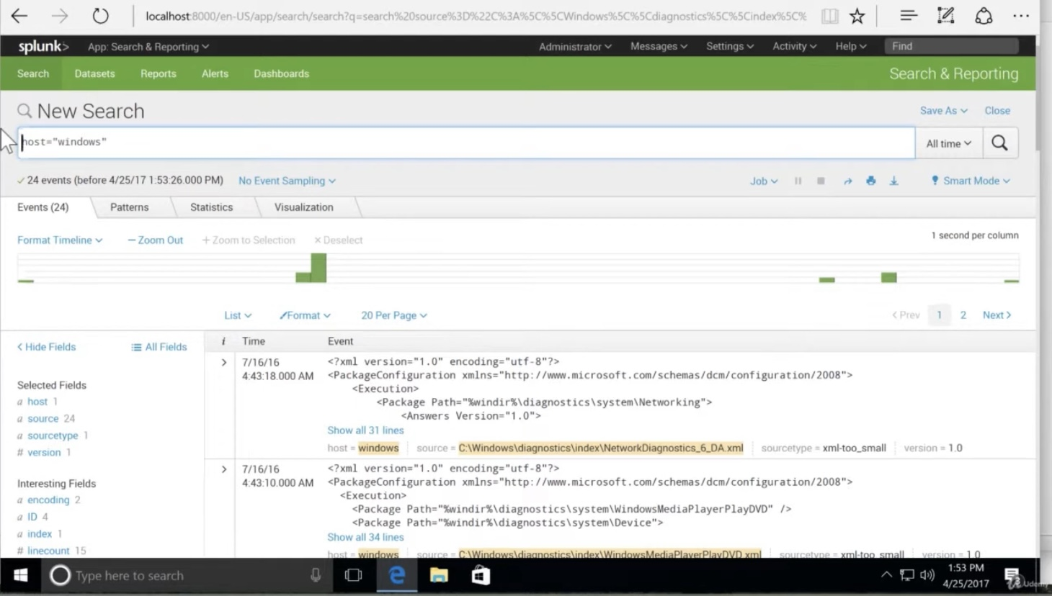

**Practical 3:**

**Universal Forwarder in Splunk**

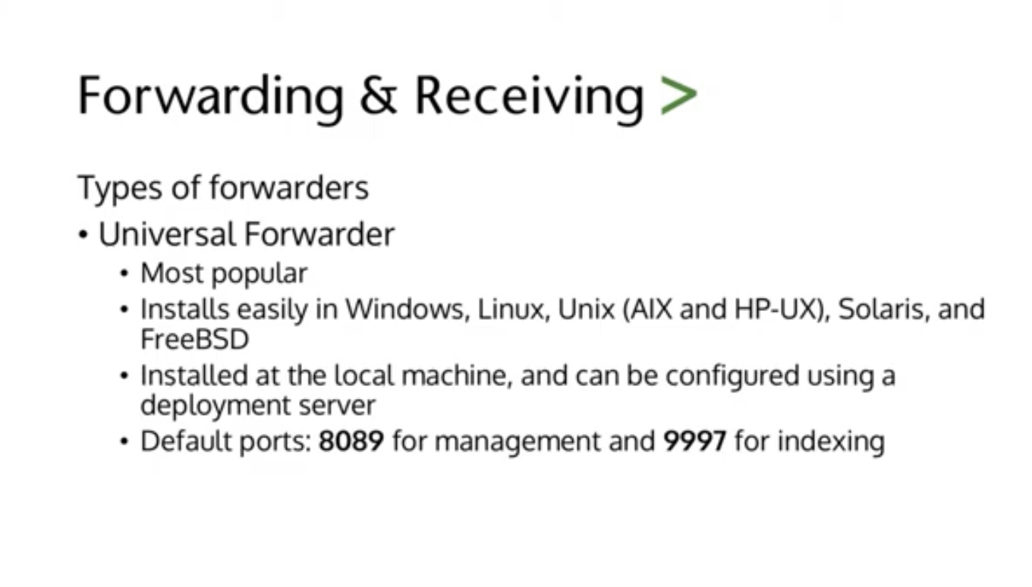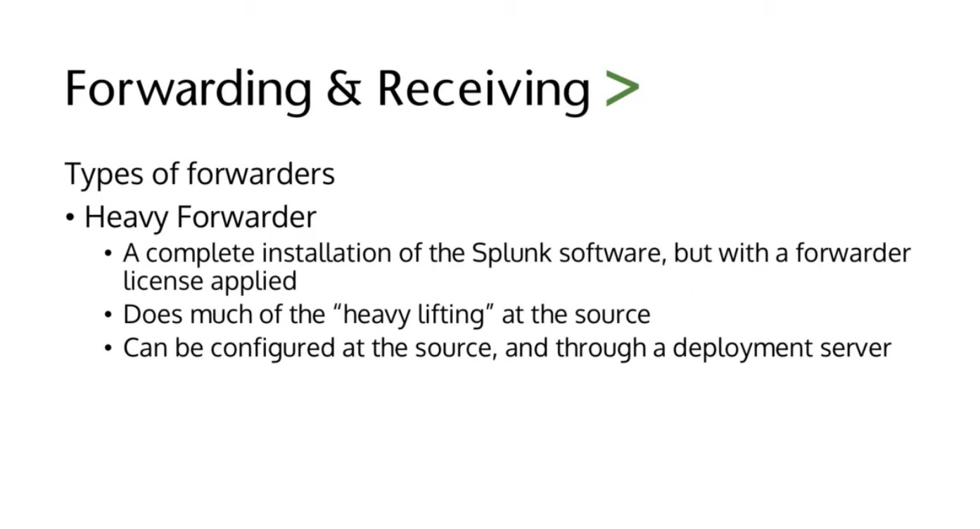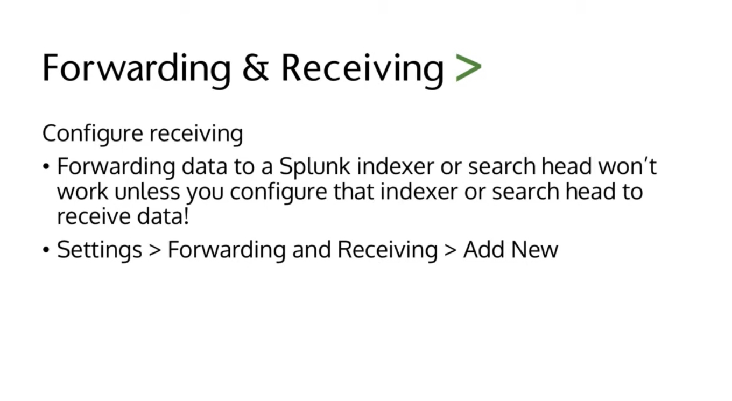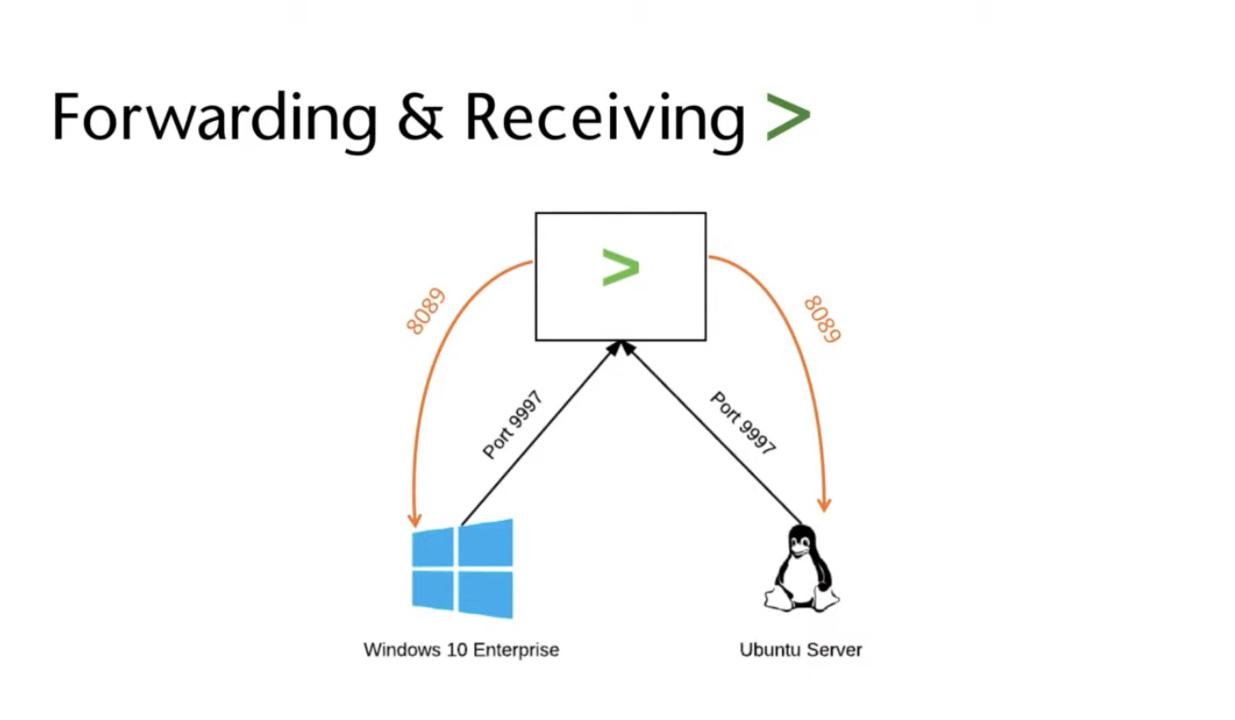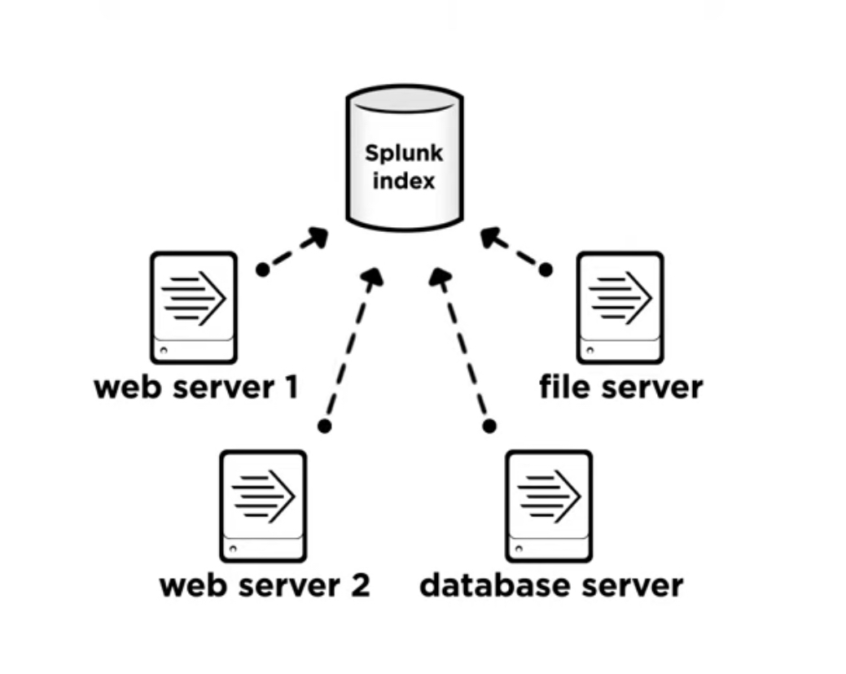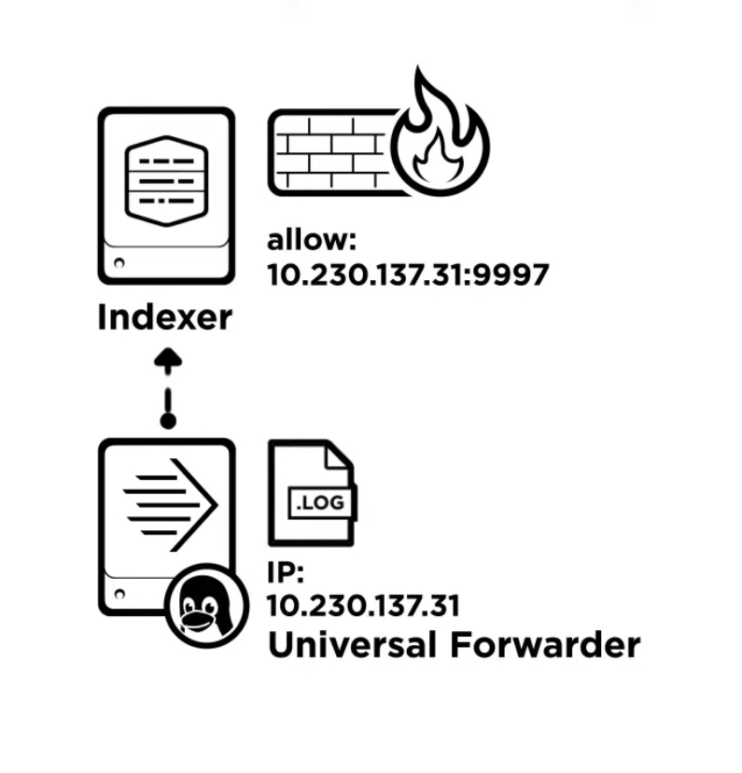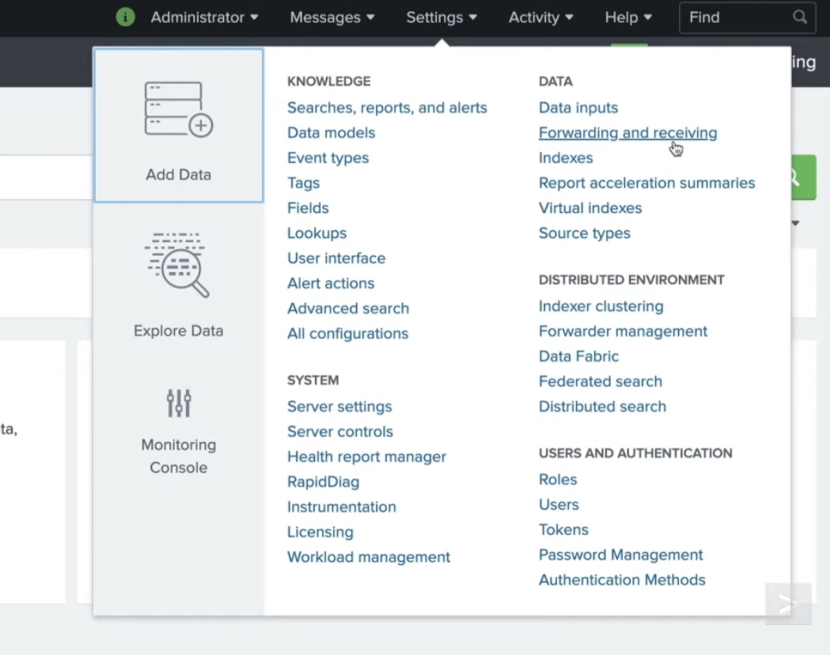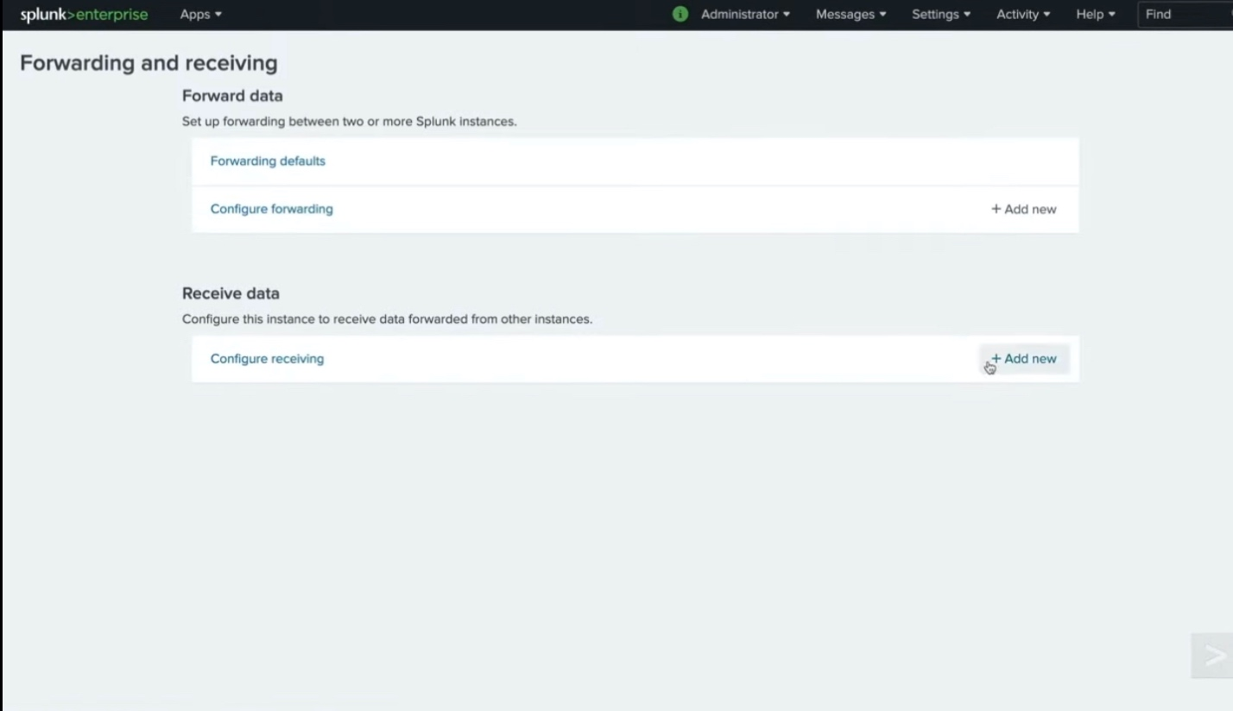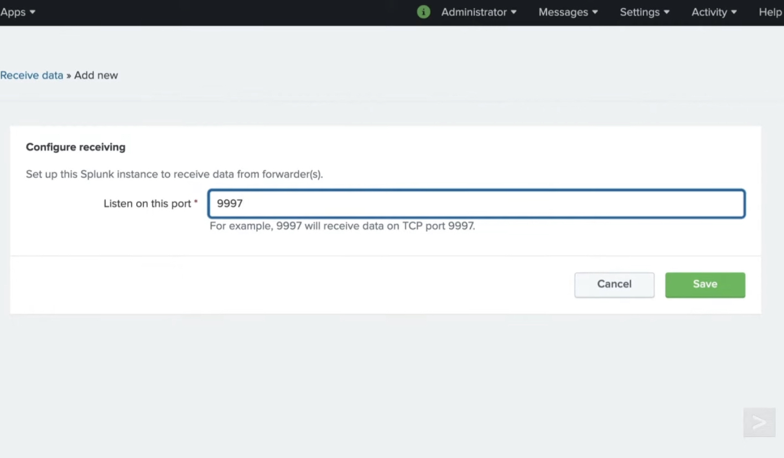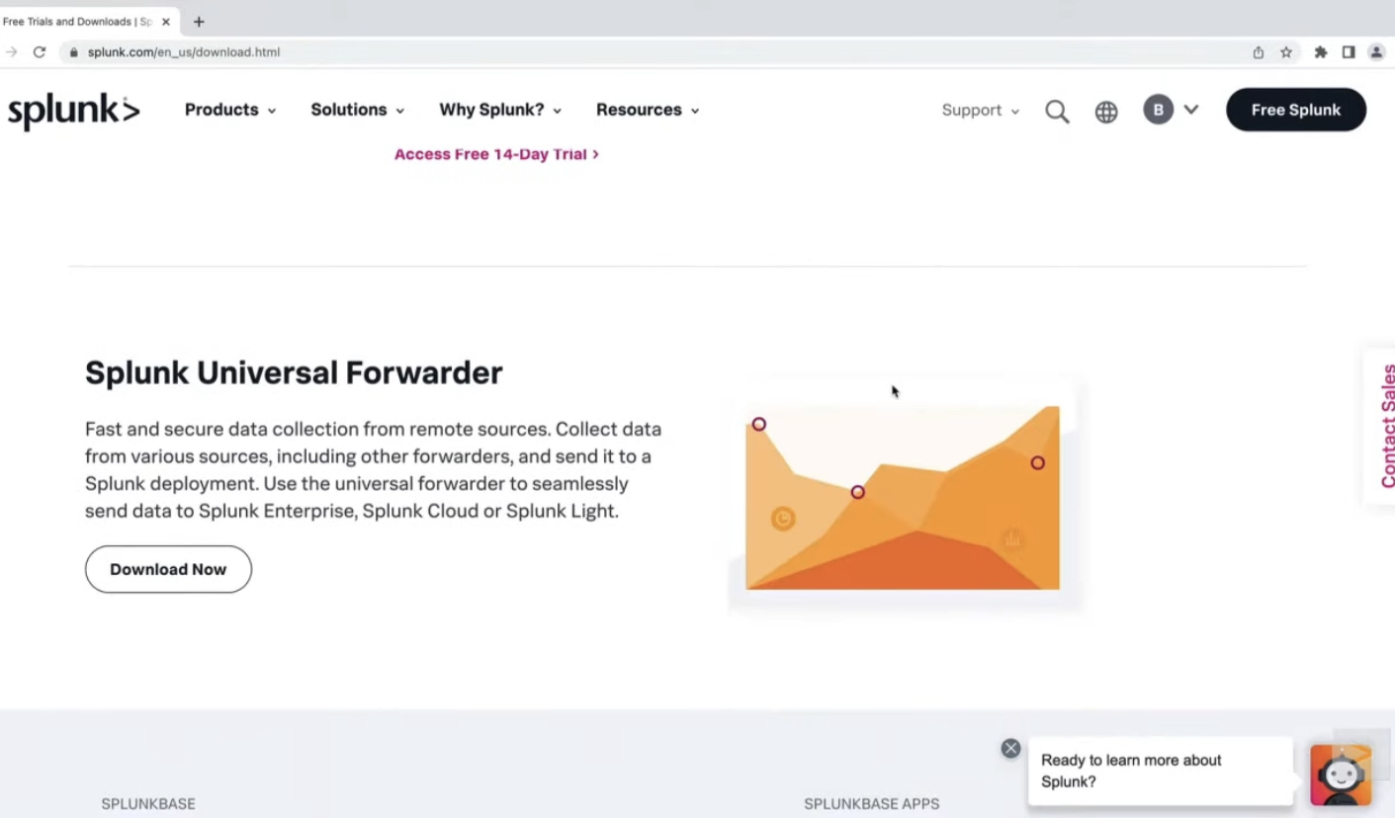

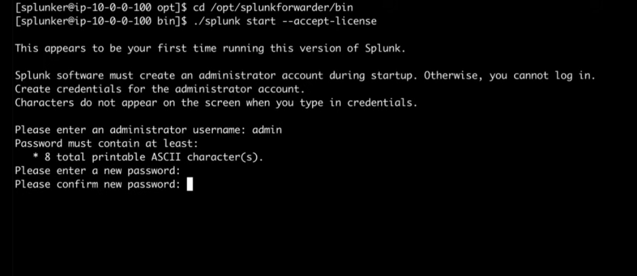

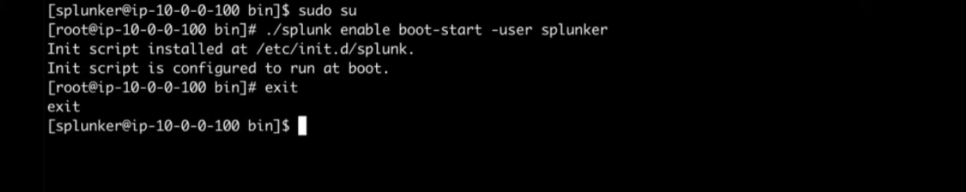

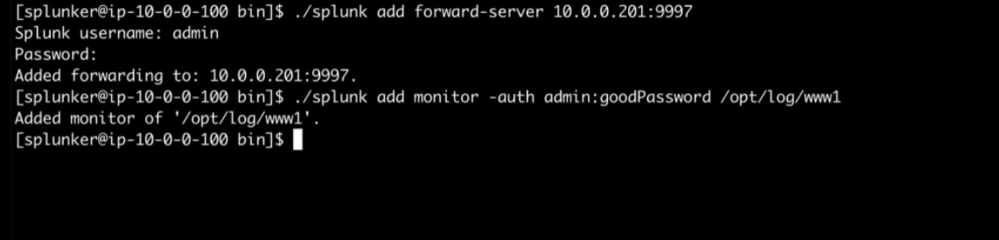

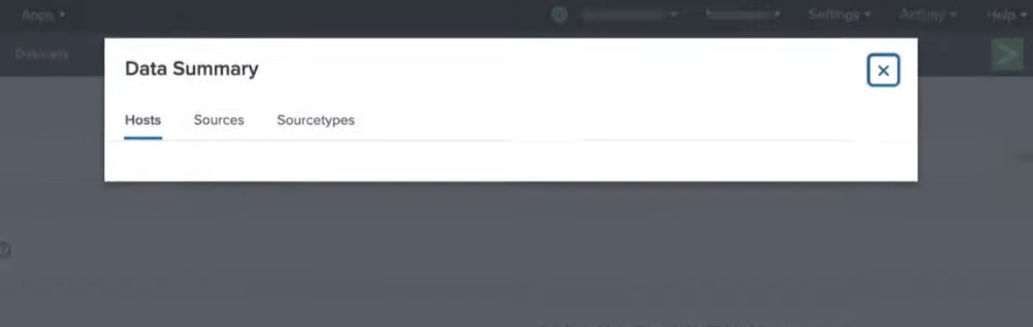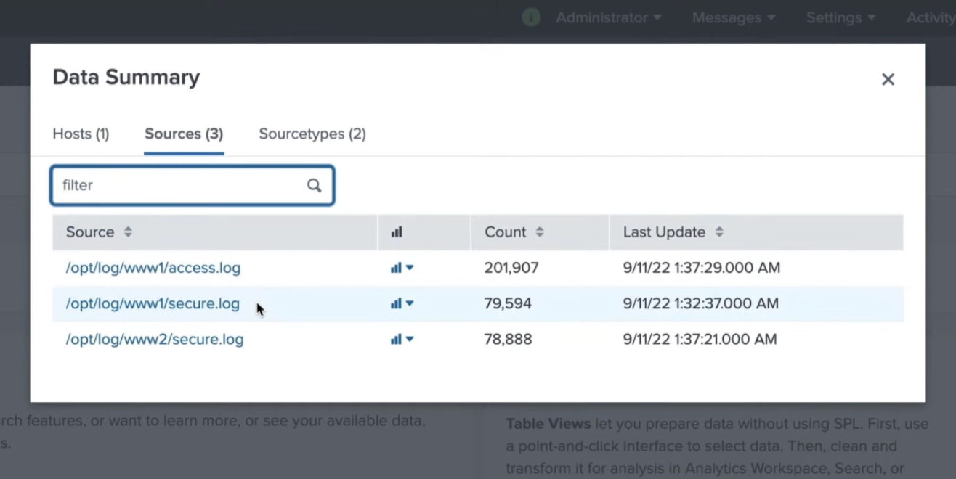

**Practical 4**

**Creating and Viewing Native Tables in Splunk**

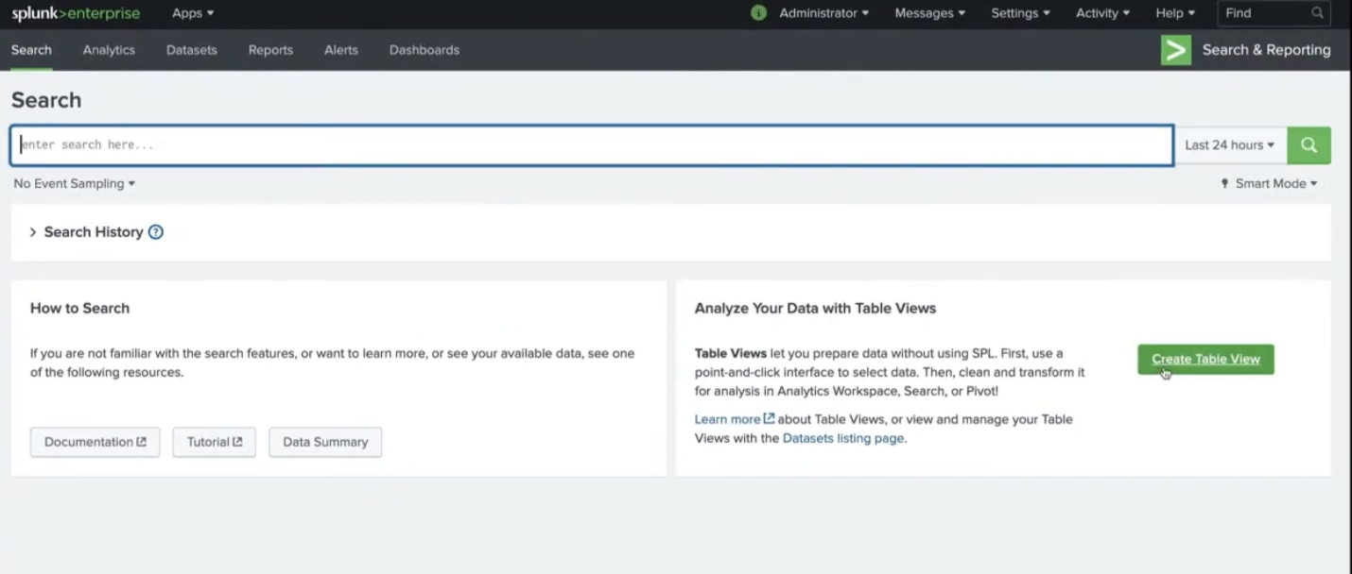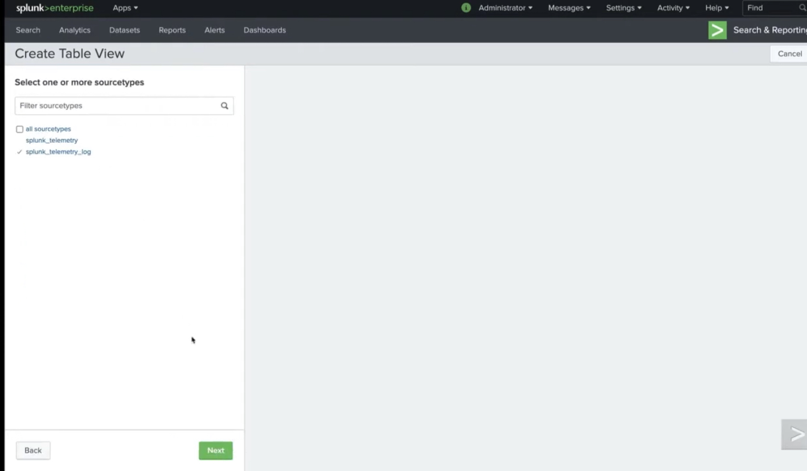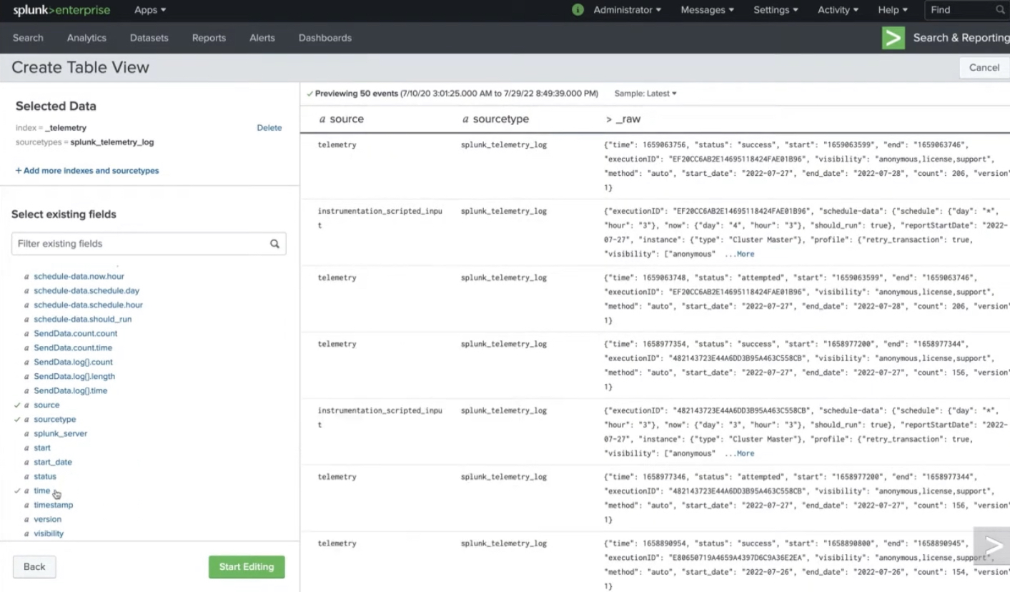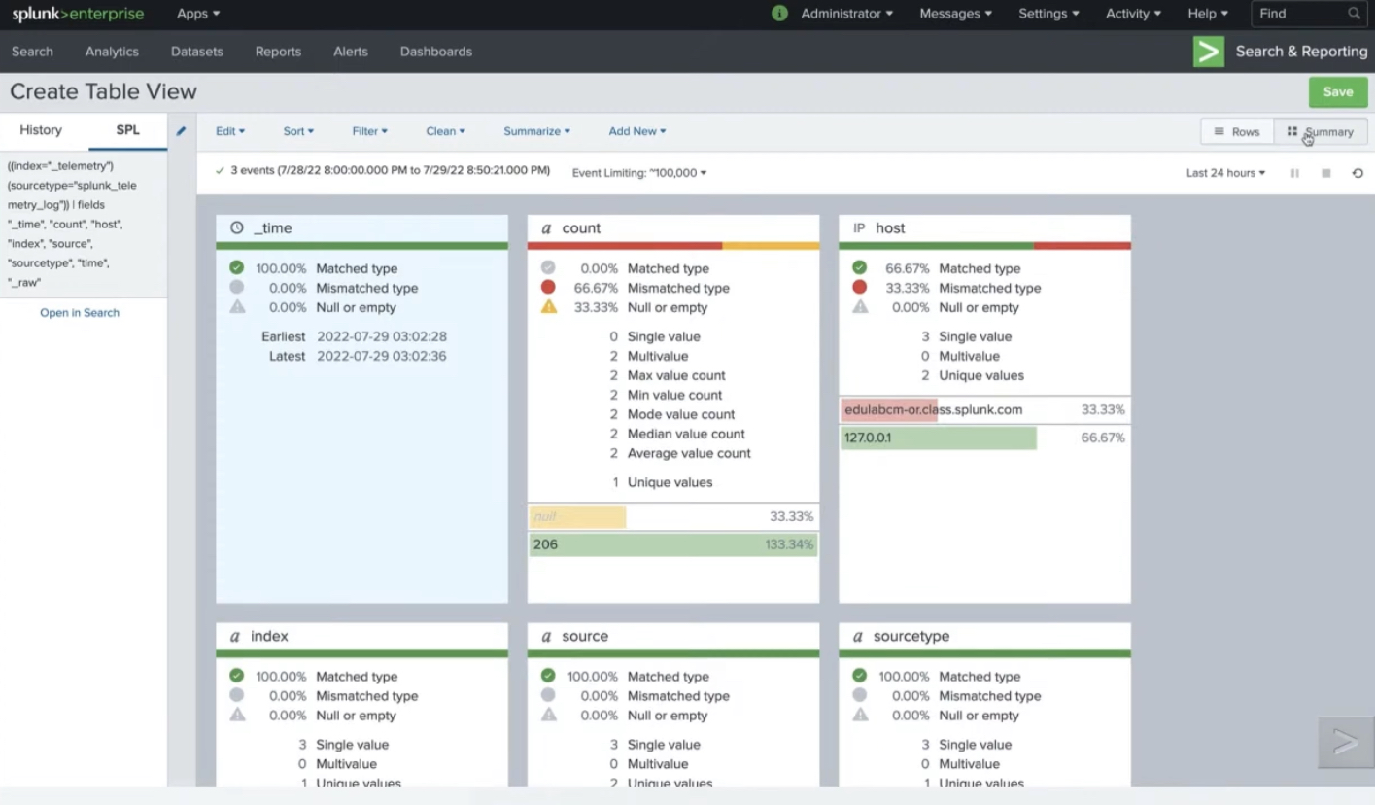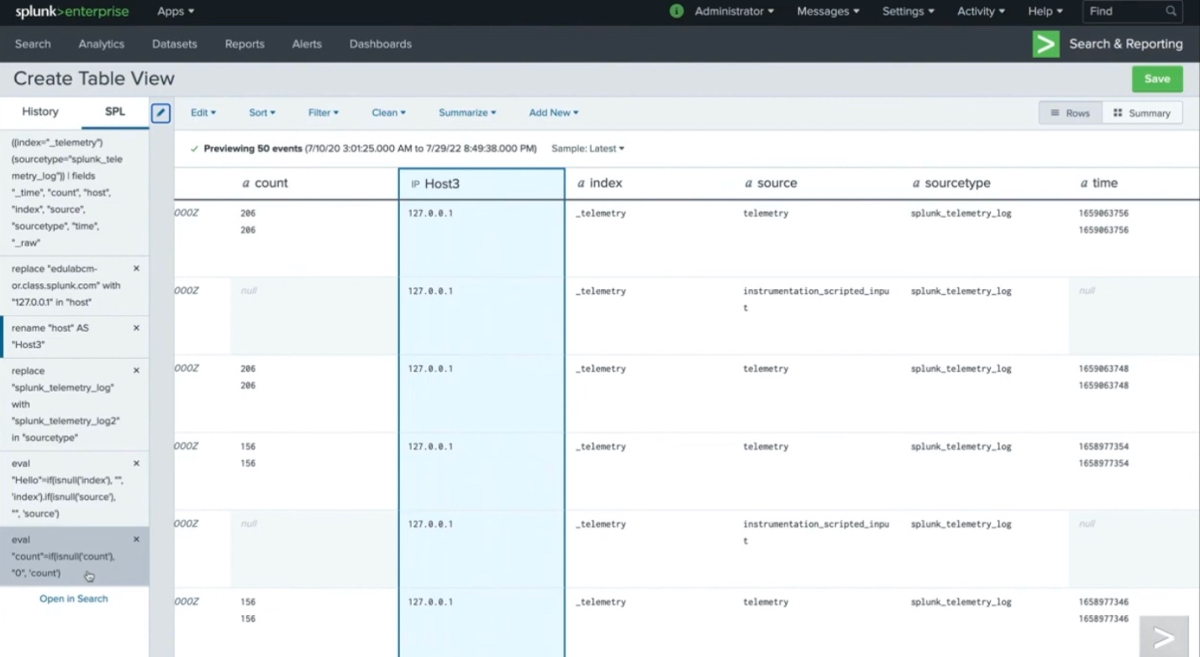

**Practical 5**

**Collect network traffic logs with WireShark and Analyse for potential security incidents.**

**Step 1: Open the Wireshark application**

First, open the Wireshark application by clicking on the icon.

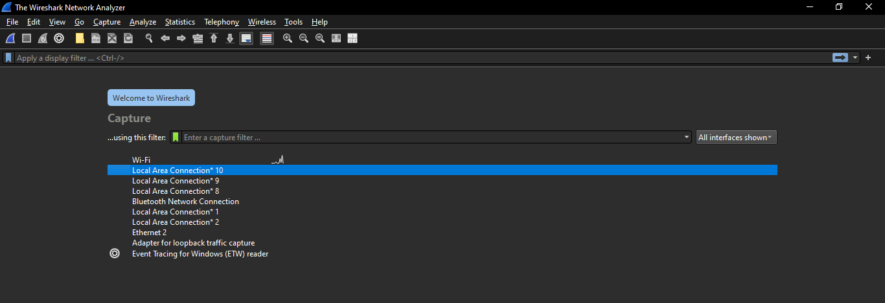

**Step 2: Select a network interface to capture traffic on**

From the welcome screen, select which of your network interfaces you want to capture traffic on. The line to the right of the interface indicates the network traffic flow passing through that interface.

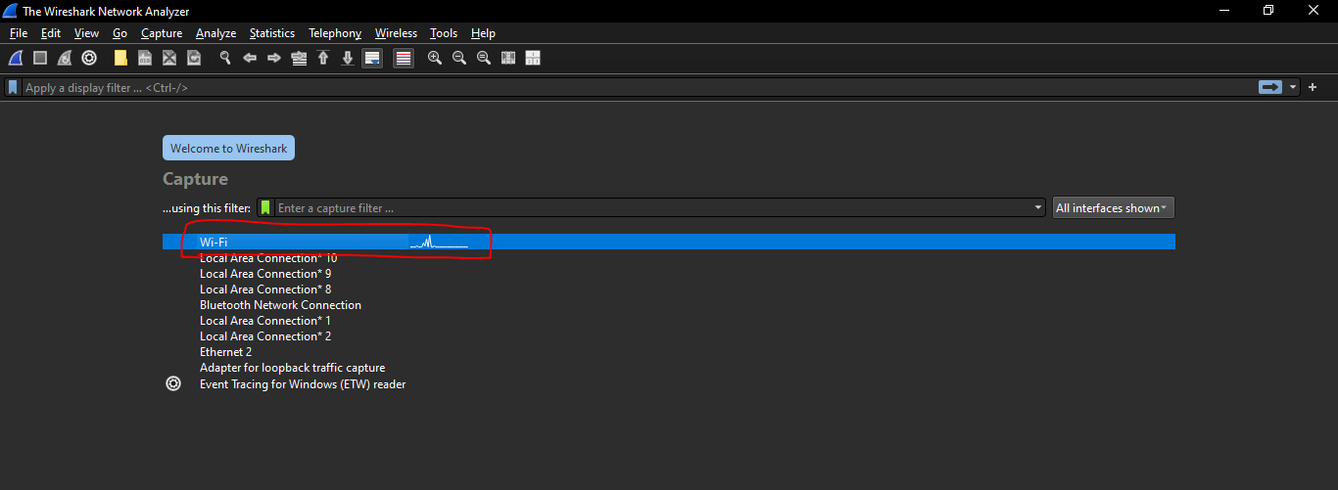

**Step 3: Stopping the packet capture**

Double-clicking on the capture interface you want to capture traffic to start capturing packets.

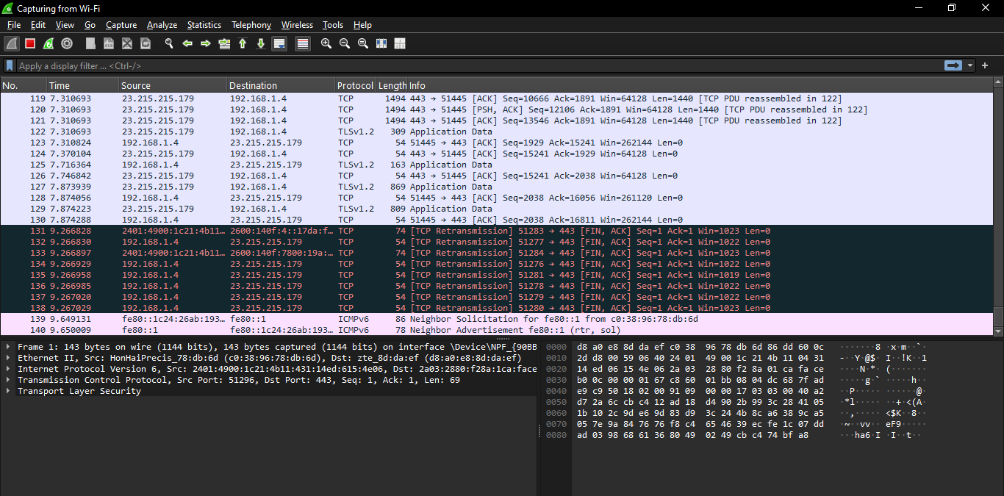

To stop capture packets, click on the red Stop Capture button.

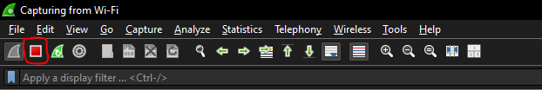

This will save the packet capture into a temporary file and allow you to perform your analysis.

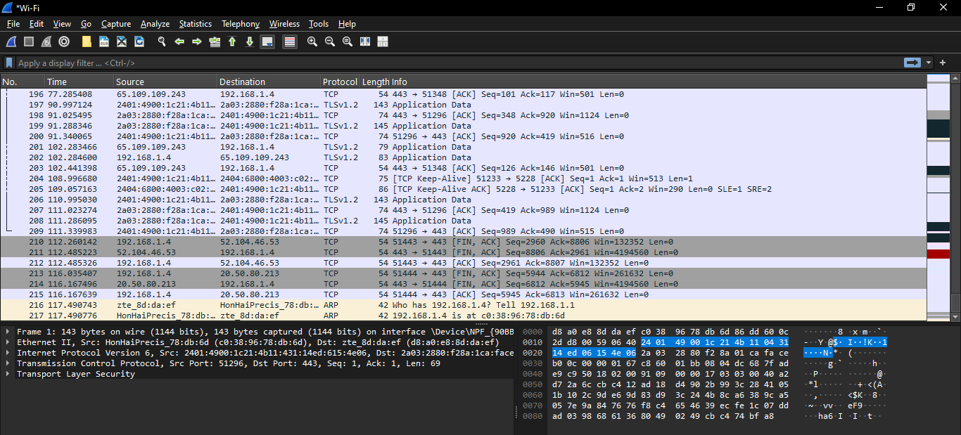

To save your data into a specific file. Select File > Save As, then enter the location and name of the file under which you want to save this data.

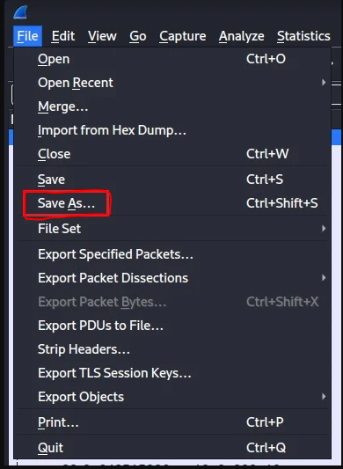

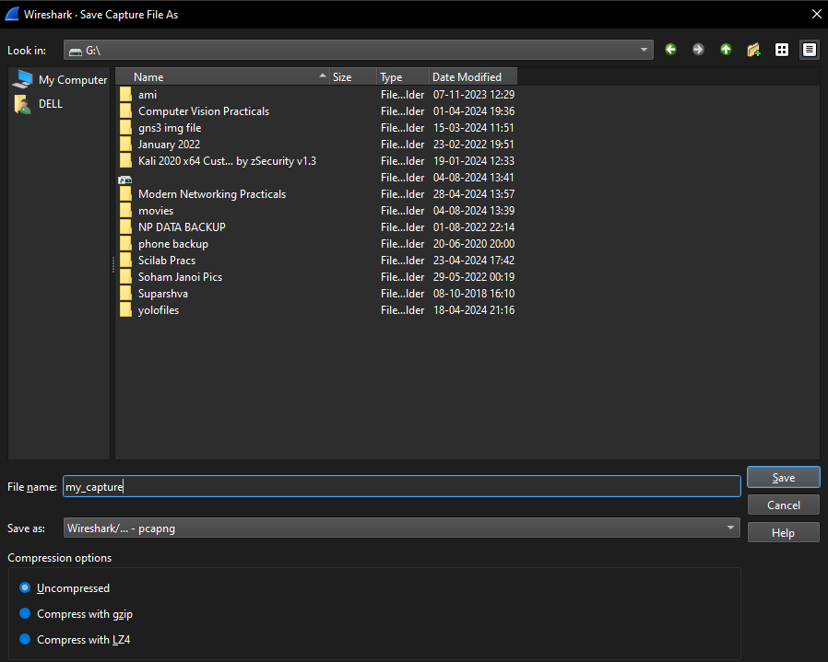

The network traffic logs will be collected.

**Practical 6**

**Examining Packets**

To examine a packet, select it within the packet list pane. This will populate the packet details pane with that packet's network information.

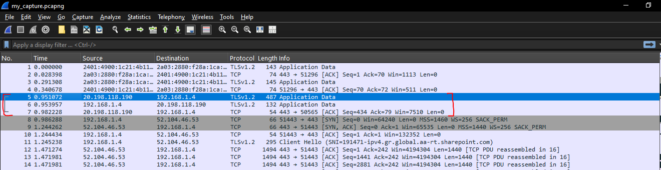

To start, you can analyze the network information at the **link layer**. This includes the source and destination MAC addresses of the two communicating devices and the type of Internet protocol used (IPv4 or IPv6).

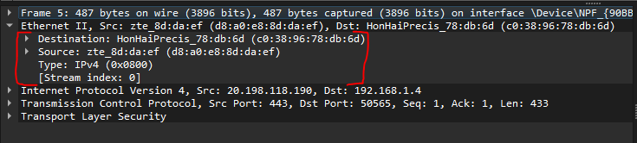

You can then move on to the information included within the **Internet layer**. This example contains information specific to the IPv4 protocol, such as IP flags, the source and destination IP address, Time to Live (TTL), the transport protocol encapsulated within this packet (e.g., TCP), and other header information.

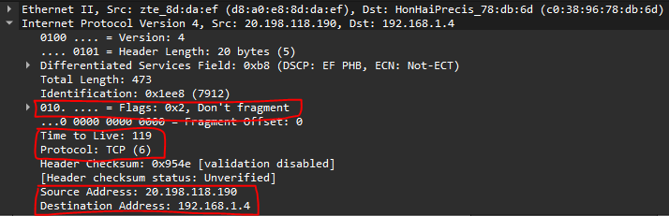

Following the IP layer is the **transport layer**. This network protocol is responsible for the end-to-end data delivery between hosts and will be either UDP or TCP. It includes the source and destination port of the segment, TCP-specific header flags, the size of the encapsulated application message, and other header information.

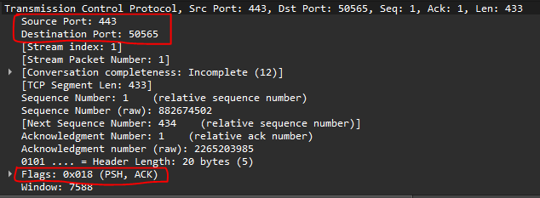

**Performing statistical analysis**

Aside from analyzing individual network packets, Wireshark also has a powerful statistical analysis feature that lets you quickly summarise your network traffic.

Select the Statistic menu from Wireshark’s main menu bar. This will provide options for showing summary information about the protocols being used, the endpoints communicating, and the network conversations between those endpoints.

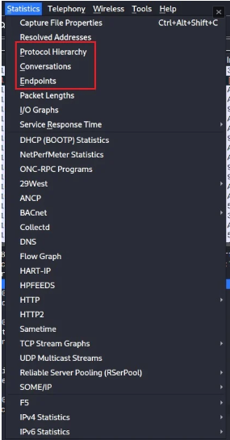

Select the Protocol Hierarchy option to discover the protocols used within your captured network traffic. This will generate a window summarizing the network protocols used at each TCP/IP stack layer.

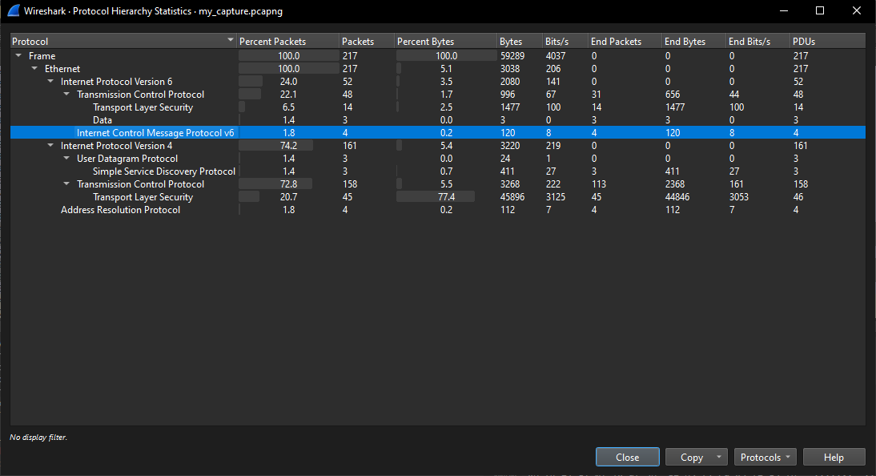

Select the Endpoints option to find out what endpoints are present in your network traffic. This will list all the unique endpoint devices communicating within the network packets you have captured based on Ethernet address, IP address, and TCP/UDP port.

In the example below, the IPv4 tab has been selected. This shows that nine devices are communicating in this packet capture, with four being the primary exchangers of data.

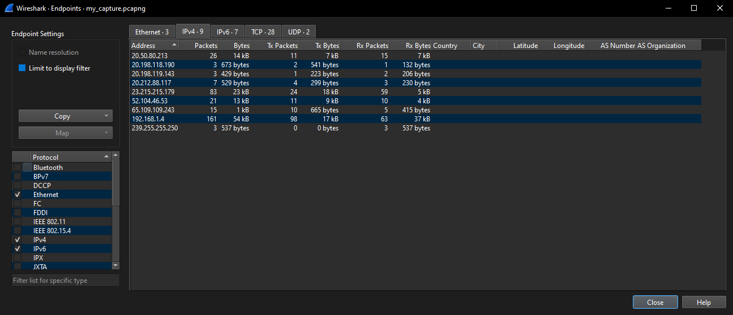

Select the Conversations option to delve into the network conversations within your packet capture. This will show you the network traffic traveling between endpoints.

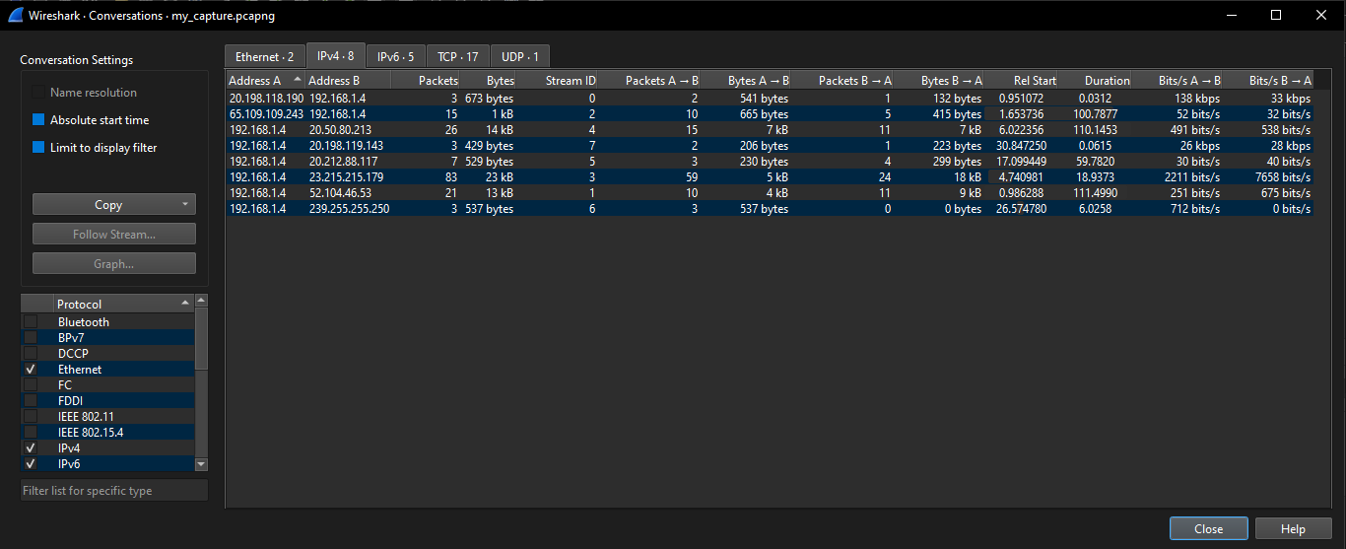

Practical 7

**Following TCP Streams**

One of the most common use cases for Wireshark is following TCP streams. By following this stream, you can see the conversation between the two devices and the data they exchanged. This is useful for troubleshooting network issues or discovering hidden information.

To follow a TCP stream in Wireshark, right-click on a packet whose TCP stream you want to follow.

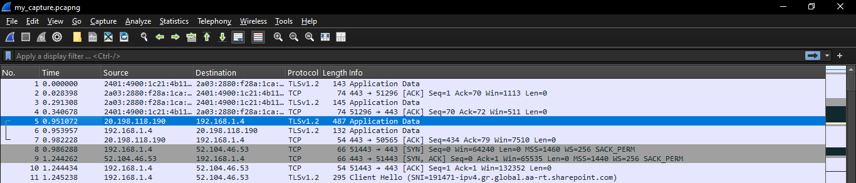

Here packet number 5 has been selected. A drop-down arrow on the left of the packet list pane indicates the entire network conversation down to packet number 7. To follow this TCP stream, right-click on packet number 5 and select Follow > TCP Stream.

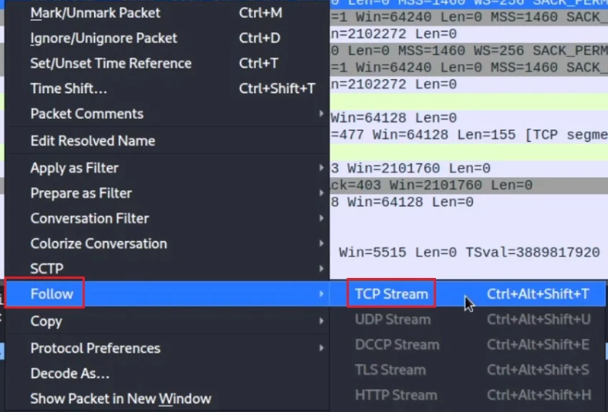

Wireshark will automatically apply a display filter that only shows packets from this TCP stream.

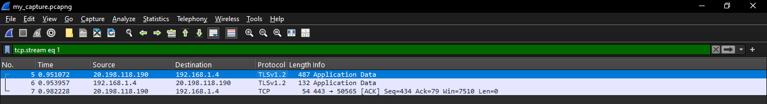

Wireshark will also generate a summary view of the TCP stream in a new window.

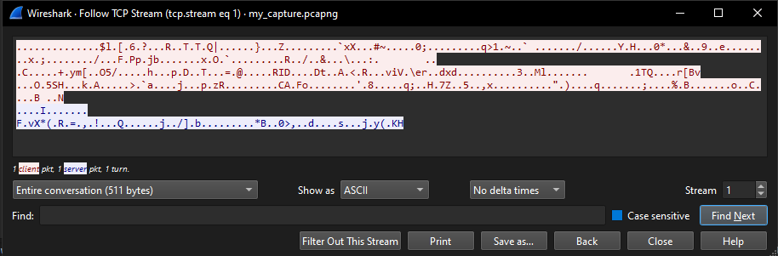

**Capture DNS Traffic**

**To capture DNS traffic:**

1. [Start a Wireshark capture](https://en.m.wikiversity.org/wiki/Wireshark/Start).







1. [Open a command prompt](https://en.m.wikiversity.org/wiki/Command_Prompt/Open).
2. Type **ipconfig /displaydns** and press **Enter** to display the DNS cache.
3. Observe the results. Notice the only records currently displayed come from the [hosts file](https://en.m.wikiversity.org/wiki/Hosts_file).

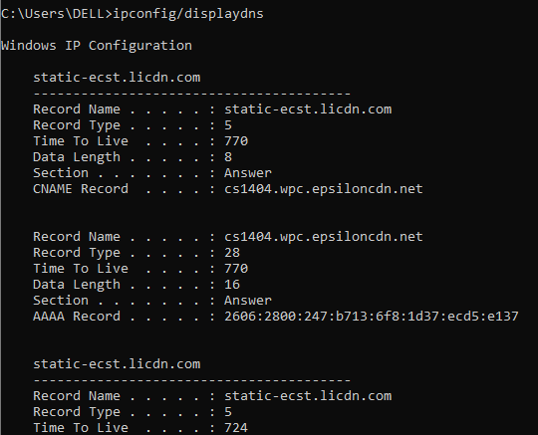

1. Type **nslookup en.wikiversity.org** and press **Enter**.

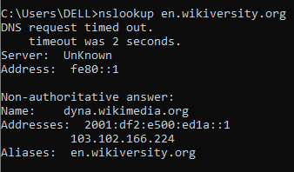

1. Observe the result. Notice there is an entry in the cache for *en.wikiversity.org*.
2. Close the command prompt.
3. [Stop the Wireshark capture](https://en.m.wikiversity.org/wiki/Wireshark/Stop).

**Practical 8**

**To analyze DNS query traffic:**

1. Observe the traffic captured in the top Wireshark packet list pane. To view only DNS traffic, type **udp.port == 53** (lower case) in the Filter box and press **Enter.**

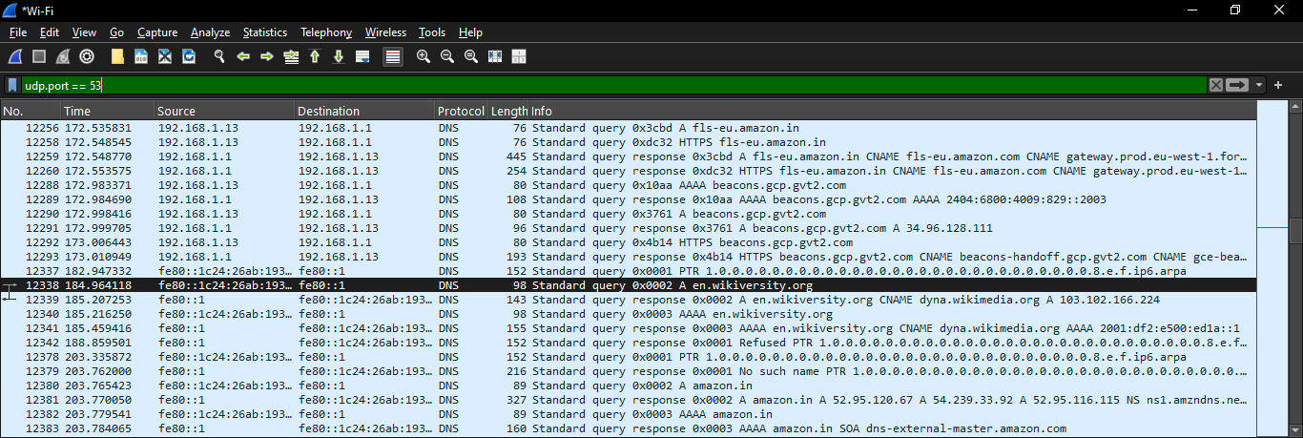

1. Select the DNS packet labeled **Standard query A en.wikiversity.org**.
2. Observe the packet details in the middle Wireshark packet details pane. Notice that it is an Ethernet II / Internet Protocol Version 4 / User Datagram Protocol / Domain Name System (query) frame.

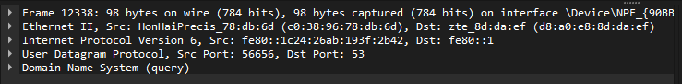

1. Expand Ethernet II to view Ethernet details.
2. Observe the Destination and Source fields. The destination should be either your local DNS server's MAC address or your default gateway's MAC address and the source should be your MAC address. You can use [ipconfig /all](https://en.m.wikiversity.org/wiki/Ipconfig/All) and [arp -a](https://en.m.wikiversity.org/wiki/Computer_Networks/Management/Utilities/Arp/View" \o "Computer Networks/Management/Utilities/Arp/View) to confirm.

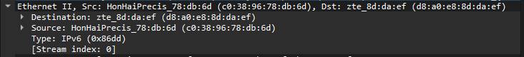

1. Expand Internet Protocol Version 4 to view IP details.
2. Observe the Source address. Notice that the source address is your IP address.
3. Observe the Destination address. Notice that the destination address is the IP address of the DNS server.

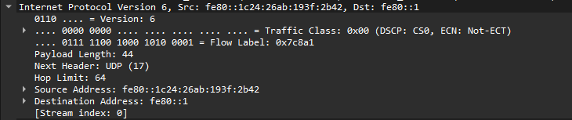

1. Expand User Datagram Protocol to view UDP details.
2. Observe the Source port. Notice that it is a dynamic port selected for this DNS query.
3. Observe the Destination port. Notice that it is domain (53), the DNS server port.

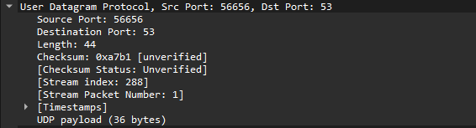

1. Expand Domain Name System (query) to view DNS details.

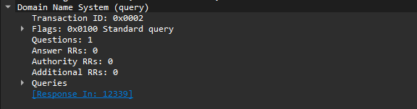

1. Expand Flags to view flags details.

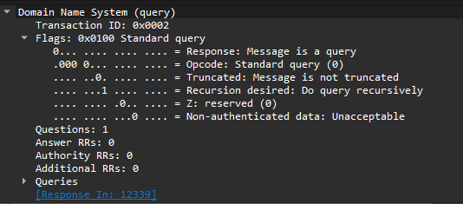

1. Observe the Recursion desired field. Notice that a recursive query is requested.
2. Expand Queries to view query details.

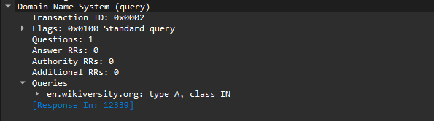

1. Observe the query for en.wikiversity.org.

**Practical 9**

**To analyze DNS response traffic:**

1. In the top Wireshark packet list pane, select the next DNS packet, labeled **Standard query response CNAME wikiversity...**.

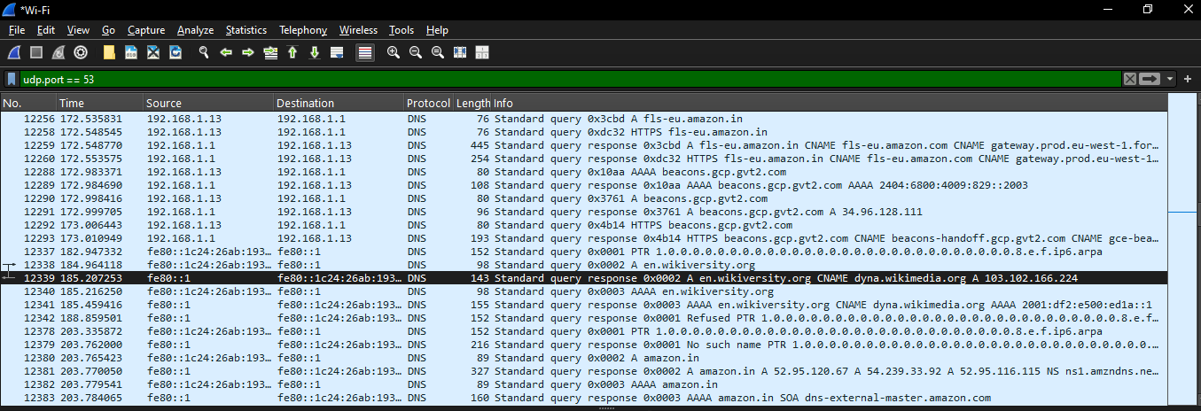

1. Observe the packet details in the middle Wireshark packet details pane. Notice that it is an Ethernet II / Internet Protocol Version 4 / User Datagram Protocol / Domain Name System (response) frame.

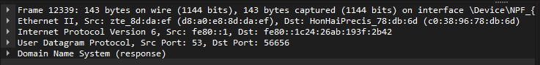

1. Expand Ethernet II to view Ethernet details.
2. Observe the Destination and Source fields. The destination should be your MAC address and the source should be your local DNS server's MAC address or your default gateway's MAC address.

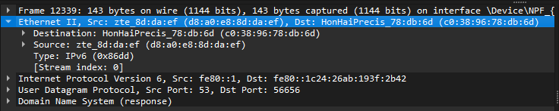

1. Expand Internet Protocol Version 4 to view IP details.
2. Observe the Source address. Notice that the source address is the DNS server IP address.
3. Observe the Destination address. Notice that the destination address is your IP address.

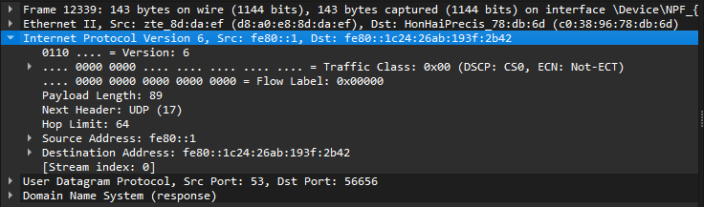

1. Expand User Datagram Protocol to view UDP details.
2. Observe the Source port. Notice that it is domain (53), the DNS server port.
3. Observe the Destination port. Notice that it is the same dynamic port used to make the DNS query in the first packet.

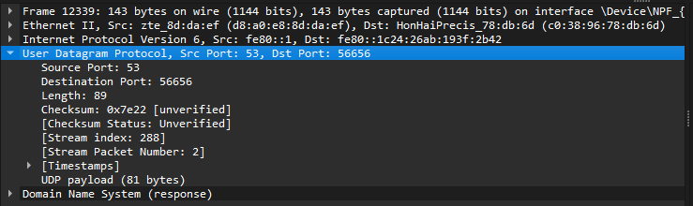

1. Expand Domain Name System (query) to view DNS details.

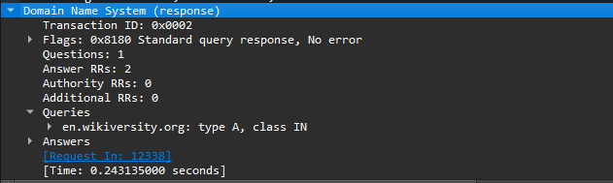

1. Expand Flags to view flags details.
2. Observe the flags. Notice that this is a recursive response.

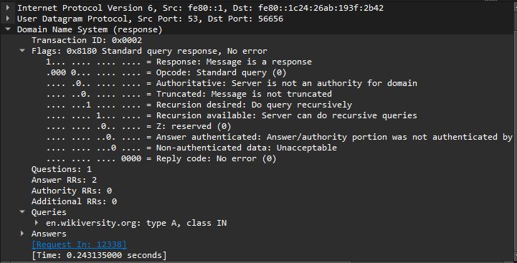

1. Expand Queries to view query details.

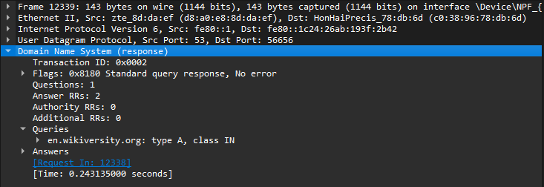

1. Observe the query for en.wikiversity.org.
2. Expand Answers to view answer details.

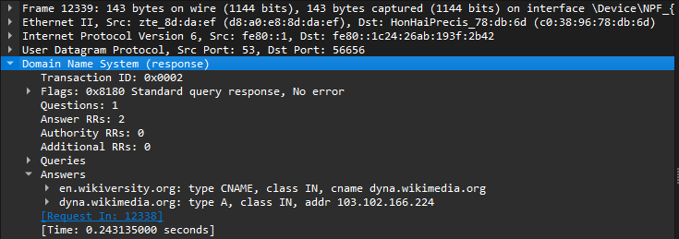

1. Observe the CNAME and A records returned in response to this DNS query.
2. Close Wireshark to complete this activity. **Quit without Saving** to discard the captured traffic.

Practical 10

Splunk Case Study for Real Time Network

Splunk is a software technology that uses the data generated by the computer to track, scan, analyze, and visualize it in real-time. It tracks and read store data as indexer events and various types of log files. It enables us to view data in different Dashboard formats.

Splunk is a program that enables the search and analysis of computer data. It analyzes semi-structured data and logs generated by various processes with proper data modeling as per the need of the IT companies. The user produces the data by means of any device like- web apps, sensors, or computers. It has built-in functionality for defining data types, field separators, and search process optimization. For the searched result, it also provides visualization of data.

Students, IT developers, and experts in IT infrastructure management who want to develop a strong understanding of basic Splunk concepts must-read study this tutorial. You can attain intermediate expertise in Splunk after completing this tutorial, and quickly draw on your skills to solve more difficult problems.

The reader should be familiar with the language of querying, like SQL. General awareness of standard operations would be particularly useful when using computer applications such as data storage and retrieval and reading computer programs generated logs.

There is a variety of benefits that are offered by the Splunk, as follows:

* Real-time screen visibility.
* Splunk offers Better Interface.
* By offering instant results, it reduces troubleshooting and time-solving.
* It is the most effective method for the study of root causes.
* Splunk permits the generation of graphs, warnings, and dashboards.
* Similar findings can be quickly checked and analyzed using Splunk.
* It enables us to troubleshoot any failure state to improve performance.
* Helps you to track and make educated decisions on every company measure.
* Splunk allows Artificial Intelligence to be incorporated into the data strategy.
* Helps you to gather useful Operational Intelligence from your system data
* Splunk allows us to recognize any data type such as **.csv, json, log** formats, etc.
* Provides the most powerful search and visualization tools to enable all types of users.
* Allows us to establish a central server, where Splunk data can be searched from various sources.

Splunk has some essential features:

* It accelerates the Development & Testing.
* The building of Real-time Data Applications.
* Generate ROI faster
* Agile figures and Real-time architecture documentation.
* Splunk also provides search, analysis, and visualization capabilities to empower users.

Splunk Versions

There are three different versions of Splunk

* Splunk Enterprise
* Splunk Light
* Splunk Cloud

**Splunk Enterprise**

Big IT enterprise uses the Splunk Enterprise Version. With the help of the Splunk tool, we can collect and analyze the data from mobile phones, websites, and applications, etc.

Features of Splunk

We are going to tell you all the features of the Business version of the Spunk.

**Data Ingestion**

In Splunk, we can import or insert the date from different data formats like - JSON, XML, and weblogs and application logs that have unstructured system data. The unstructured data can be modeled as the consumer wants in a data structure.

**Data Indexing**

plunk indexes the ingested data for speedier search and query on different conditions.

**Data Searching**

Splunk analysis involves using the indexed data to establish graphs, to forecast future trends, and to find patterns in the data

**Using Alerts**

Used to trigger emails or RSS feeds when a certain requirement is identified in the data that is being analyzed.

**Dashboards**

When we searched anything, the search result is displayed in the dashboard in the form of maps, reports, pivots, etc.

**Data Model**

The indexed data may be modeled into one or more data sets based on domain expertise. It leads to more straightforward navigation by end-users who evaluate the business cases without understanding the language techniques used by Splunk to process information.

Important Blocks of Splunk useful for SOC:

* Splunk Attack Analyzer automatically navigates complex attack chains to detect credential phishing and malware threats, generating actionable insights and reducing the friction of repetitive manual tasks typically associated with investigating threats.
* Splunk Asset and Risk Intelligence is a security application that can help you discover assets on your network and shorten your investigations.
* Splunk Enterprise Security provides prebuilt content and searches to help focus security analysts on answering root-cause questions in real-time about malicious and anomalous events in the IT infrastructure.
* Splunk User Behavior Analytics detects unknown and hidden threats using unsupervised machine learning, reducing the need for manual baselining, rule creation, and customization.
* Splunk Security for SAP solutions provides powerful, data driven security functionality for threat hunting, risk reduction, and vulnerability mitigation. The solutions include the Splunk Security Add-on for SAP solutions and the Splunk Security App for SAP solutions.

# Splunk Infrastructure Monitoring, It Gain insights into and perform powerful, capable analytics on your infrastructure and resources across hybrid and multi-cloud environments with Splunk Infrastructure Monitoring. Infrastructure Monitoring offers support for a broad range of integrations for collecting all kinds of data, from system metrics for infrastructure components to custom data from your applications.

Important Links for case study:

1. <https://www.splunk.com/en_us/customers/success-stories/splunk-at-tesco.html>

2. <https://www.splunk.com/en_us/customers/success-stories/splunk-centurylink.html>

3. <https://www.splunk.com/en_us/customers/success-stories/tokyo-stock-exchange.html>

4. <https://www.splunk.com/en_us/mclaren.html>